This is the family tree of Mrs Jenny Thornton, the great, great, great granddaughter of John Yorke, the African slave, baptised in Marske in 1776. There would be no photos of William Yorke, John’s son who was born in 1803 and became a prizefighter because the time was before photography was invented.
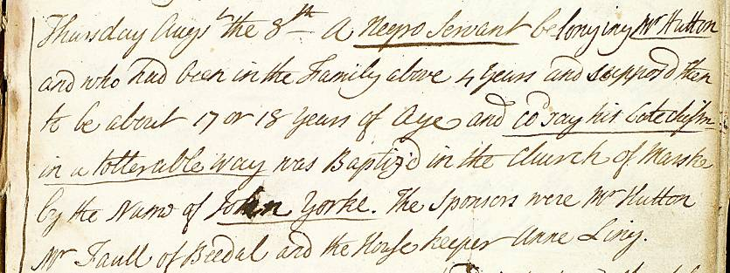

John Yorke (the African) = Hannah Barker

William Yorke = Mary Knaisby
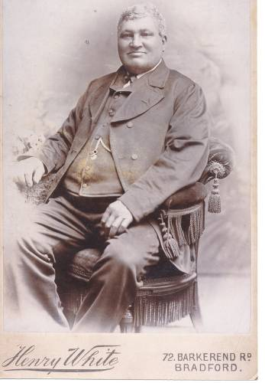

George Yorke = Margaret Kipling
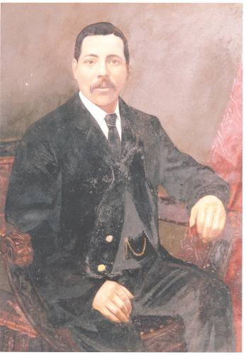

John Yorke = Ada Jackson
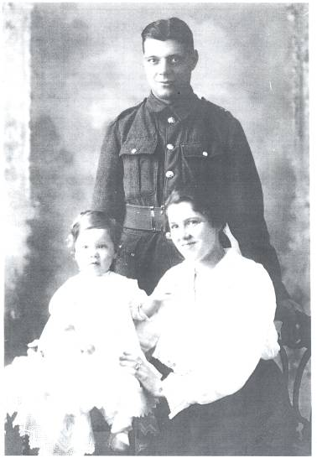

Tom Yorke = Mary Watkinson
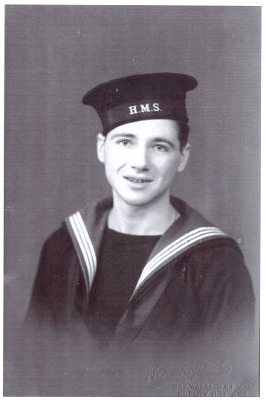

Kenneth Yorke = Audrey Harrison
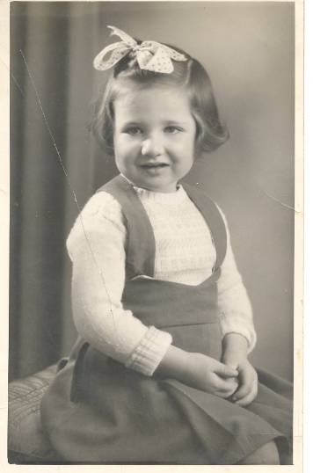

Jenny Thornton (nee Yorke)

