Build a Working Roman Groma

This activity sheet accompanies the learning resource ‘Roman Roads’. The resource covers why and how the Romans built roads in Britain, as well as how to use a groma.
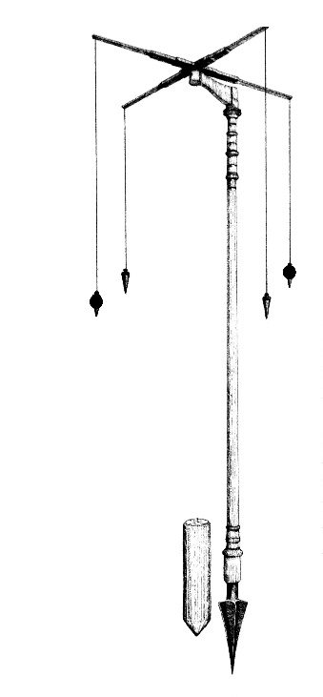
Equipment list
- Corrugated plastic sheet or thin balsa wood
- 1 metre length dowelling
- Pencil
- Ruler
- String
- Scissors or craft knife
- Adhesive
- Split pin
- Awl
- Blu-tac
- Cutting board

Time
30 - 60 minutes
Illustration of a Roman groma | Wikipedia

About this activity
The Romans built incredibly straight roads between towns and cities in Britain, but how did they manage this without the technology we have today? This activity involves building a groma, the surveying instrument used by the Romans to plot the most direct line between two places, even when there was no line of sight between them.

Instructions
- Measure and cut two 40cm x 4cm strips from the plastic sheet / balsa wood.
- Use an awl to punch a hole half-way along the strips. These are the arms of the groma.
- Fix the strips together at right angles, forming a cross shape. Make sure the holes line up.
- Punch a small hole at the end of each arm of the cross. This will be to attach the string.
- Measure and cut out one 10cm x 4cm strip from the plastic sheet / balsa wood.
- Punch a hole at both ends of the strip.
- Use the split pin to attach the cross shape to one end of this strip. Make sure the cross can rotate.
- Thread the long dowel through the hole in the other end of the strip. Use blu-tac to prevent the arm slipping down the dowel.
- Cut four 30cm lengths of string.
- Attach one end of each string to the end of each cross arm, and a small blob of blu-tac to the other end of each strings to act as a weight.

Diagram of a groma
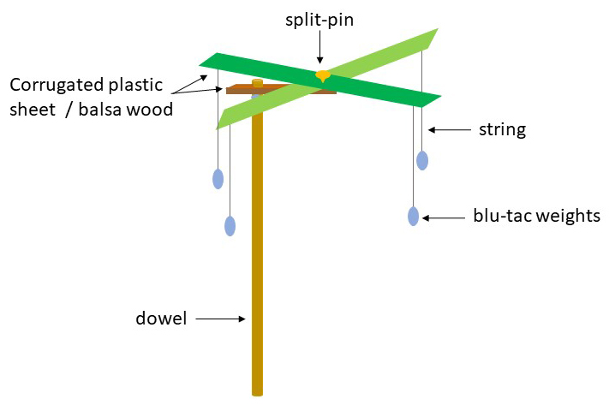

Caution
Adult supervision is recommended if using a craft knife to cut balsa wood, and when using the awl. Make sure to use a cutting mat and keep fingers away from the blade.

When using the awl, place the strips on a flat surface and on top of a cutting board and press directly down with the awl.

If using corrugated plastic sheet, make sure the corrugation runs along the length of the strips to help keep them rigid.

Using the Groma
Challenge pupils to plot a straight line between two points, or use a groma to plan out parallel race tracks, or plot a sports court / pitch.

