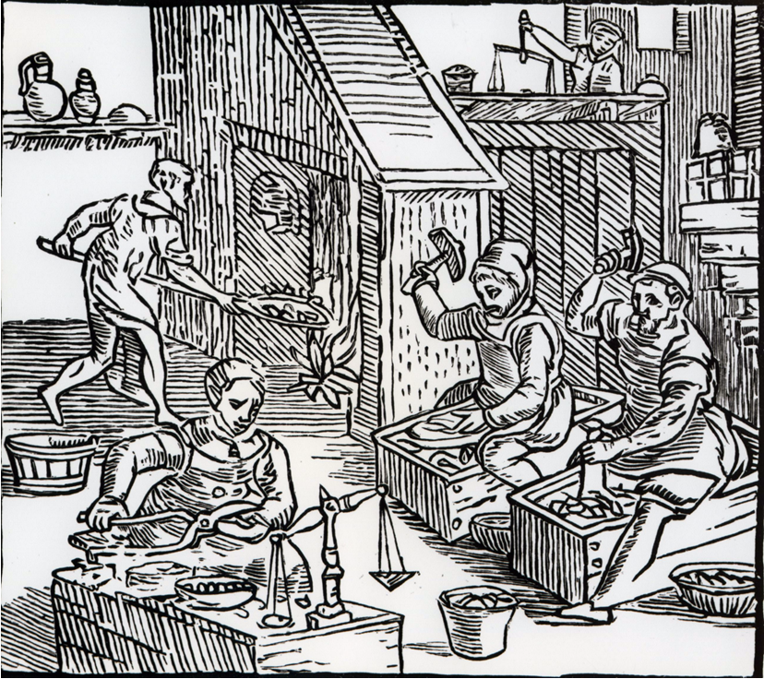

Coiner Picture Activity

Who is clipping the coins?

Who is melting the pieces down?

Who are using the coin dyes to make the marks on the coins?

Who is weighing the coins to try and make sure their weight are roughly the same?

