Newgate Prison – “Hell above ground!”

A Brief History of Newgate
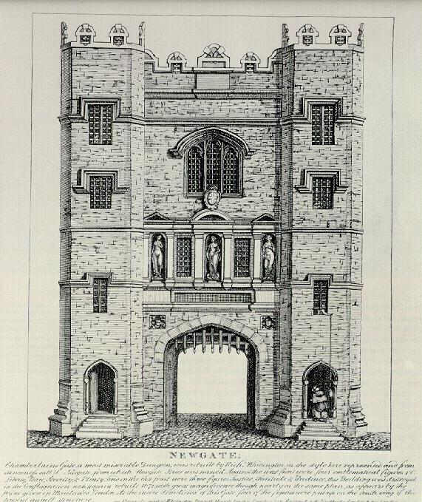
Newgate prison had been around since the 12th Century. It had been destroyed in the Great Fire of London (1666). It was rebuilt four years later. It came into it’s own as London’s most notorious prison in the 18th Century. It was built solid, like a cast and had a reputation for being impossible to escape from.
Until Victorian times Newgate was run in pretty much the same way as it had been since Tudor times. Prisoners were not properly classified and no real effort was made to separate serious offenders from low risk prisoners. Serious murderers and thieves could be put into the same cells and children too.
If you had money you were put in the most comfortable part of the prison and (so long as you kept paying) had access to good food, drink and better treatment. If you didn’t have money you were placed in damp, cold and overcrowded parts of the prisons. You were underfed and had to look after yourself. This was all perfectly legal. Gaolers (or turnkeys as they were called), received no fixed wage and so they were allowed to take a percentage of much of the money charged. Naturally this led to corruption, extortion, and a general abuse of power.
Until the late Victorian period nobody served lengthy prison sentences. If you had done something serious you would be hanged for it. Otherwise you might be whipped, branded or put in the stocks. During the Georgian era (1700s) transportation to America or Australia was added to the list of punishments. Prison was basically a holding place where you waited to be put on trial, served short sentences, or waited to be taken somewhere else and punished.
The poor of London hated Newgate and it came to symbolise everything that was oppressive about Georgian society. An attack on Newgate was seen as a victory for the poor against the rich. In the early 18th an extremely popular thief named Jack Sheppard escaped twice in the same year (1724) from Newgate prison. His spectacular escapes made him a folk hero
In 1780 London experience the worst riots it had ever seen. The riots were called The Gordon Riots. In a week of violence between 800-1000 people were killed. Many buildings were attacked. Most famously Newgate was overrun, burned down and 3000 prisoners were set free. This attack is described in colourful detail in Charles Dickens novel Barnaby Rudge.

Newgate in the time of Elizabeth Fry
In the early 19th Century (1800’s) Newgate had improved slightly. Guards were not allowed to charge prisoners fees but the prison still discriminated against the poor and favoured the rich. This was mainly because the system of buying luxuries was still in place. Prisoners were still not classified properly; men and women were kept separate from each other and those waiting for their trial were kept separate from those who had already been sentenced, but that was as far as it went.
There were eight court sessions a year. This ensured the prison was constantly filling up, emptying and filling up again, mainly with prisoners waiting to be transported to Australia.
The prison was divided into two sections, the “tried” and the “untried”. The untried section contained the lesser number of prisoners. Fry’s experiment concentrated more on the tried side of the prison.
Despite minor improvements the women’s prison at Newgate was known as “Hell above ground.”

Newgate Statistics when Elizabeth Fry gave evidence to Parliament in 1818
(Taken from Fry’s Parliamentary Testimony)

Number of Prisoners | Male | Female
“Respited during pleasure” | 48 | 8
“Waiting for the judgement of the court” | 12 | 2
“To be transported for life” | 14 | 14
“To be transported for 14 years” | 9 | 10
“To be transported for 7 years” | 60 | 33
Total number of prisoners  (not all are included above) | 460

Glossary
Classified: Sorted into different kinds, labelled.
Gaolers: Prison wardens.
Corruption: Dishonesty such as taking bribes.
Extortion: Blackmailing someone with threats.
Transportation: In this context it means criminals sent to another country (often Australia) by ship.
Oppressive: Harsh and cruel.

