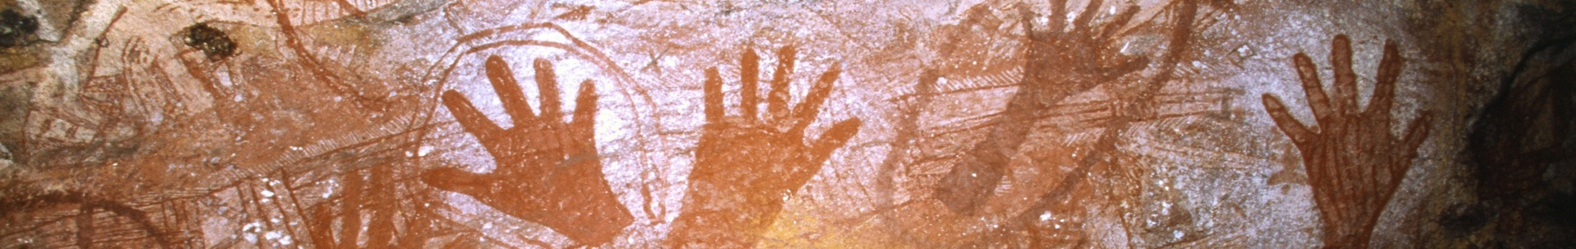
Art and Empire Interpretation Guide
Leeds

This guide was designed to help researchers, teachers and learners interested in exploring art objects connected to British colonial history in Leeds. It can be used to create interpretation materials for objects in collections and communities, and
learning materials around art rooted in structures of British imperial/colonial power. These structures included but were not limited to transatlantic slavery, the
colonisation of land and people, geopolitics (reform and policing), military conflict, imperial trade and wealth accumulation.

Title of artwork/object:

Date made:

Briefly describe any significant historical events from the period the object was made. Use the colonial structures outlined above as a guide.
Is the object connected to these events in any way?

Briefly describe the materials the object made from:
What type of object is it?
Where do these materials come from?
Were they imported into Britain through trade routes?

Briefly describe the overall appearance of the object
What is the subject matter?
Are there any visual connections to British colonial/imperial history?

Briefly describe the object's acquisition history:
Where was it originally made?
When was it brought to Leeds?
How much (if anything) was paid for the object?
Where had the object been before it came to Leeds?

Briefly describe the maker of the object.
What was their profession?
What was their connection to Leeds, if any?
What other works have they made?
What were they well known for and what are they known for today?

If the object includes a representation of a person, describe that person.
What was their profession?
What was their connection to Leeds, if any?
How do they appear in the work?
What were they well known for and what are they known for today?

Do you have any other thoughts about the object?

