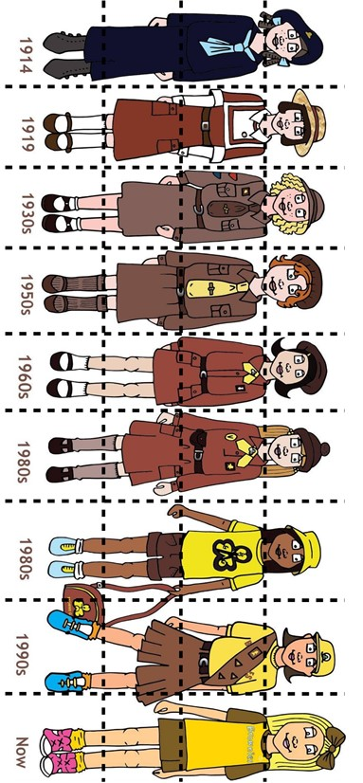
Brownie Fashion Timeline Puzzle

Teacher notes:
Cut along the dotted lines and provide the pieces to pupils. Pupils can work individually or in pairs to reconstruct the timeline. Clues that provide some history and context to the uniform changes are in the table on the next page and can be used to help pupils complete the puzzle.
To make it more difficult, the table of clues can also be cut up and then matched to the correct, completed illustration

Date | Description
1914 | The only uniform that wasn’t brown in colour. Inspired by military fashion, girls wore a beret type hat called a tam.
1919 | Brown is used for the colour of the uniform for the first time. The beret is replaced with a straw hat. Skirts are slightly shorter, but still worn long.
1930s –1940s | The shade of brown changes and a brown tie is brought in. The uniform then stays the same for the next 20 years due to WW2 and the rationing of clothes.
1950s | A lack of money and resources after the war meant only small changes were made. Older Brownie uniforms could be worn along with newer ones and not look very different. Berets were brought back.
1960s | Following fashion, the length of the Brownie skirt becomes shorter. Brownies still wear a beret.
1980s | Small changes were made. A bobble hat was brought in to replace the military style beret, and a leather purse is introduced and worn on a belt.
1980s | A leisure wear option was introduced and could be worn during residentials when Brownies were doing outdoor activities. Cheaper dyes meant brighter colours like yellow could be used for more of the uniform.
1990s | A ‘mix and match’ style was introduced, including T-shirts, jumpers and shorts. For the first time, Brownies had more choice and could wear a uniform that reflected their personal style. Badges were sewn onto sashes.
Now | The uniform was re-designed using the same mix-and-match style. A choice from long and short-sleeved t-shirts, hoodies, gilet, leggings, trousers, skort, cycle shorts and baseball cap along with a sash can all be worn.

