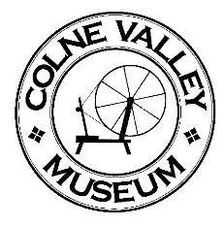
It Didn’ Seem Reet

Wen a fella come walkin’ daarn owr road,
‘Is clogs went “er-clatt, er-clatt.”
An’ it struck mi, as Ah’d never knowed
A pair o’clogs t’ saarnd like that.

So Ah waited wile ‘e wos getten close,
Fer t’ see wot wer t’ matter,
Clogs doant go “er-clatt, er-clatt” tha kno’s
Ther should go “clatt-er, clatt-er!”

Ah thowt, “Just wen ‘e passes mi
Ah’ll ‘ev a look a’t’ graarnd”,
Cause Ah wer fair reet wonderin’
O’er t’ reason fer yon saarnd.

So wen ‘e sed, “Nah then thee, “
Wen ‘e passed mi in t’ street,
Ah looked, an’ does tha kno’s
Booath ‘is clogs wer ont’ wrong feet.

Anon

