EDUCATION
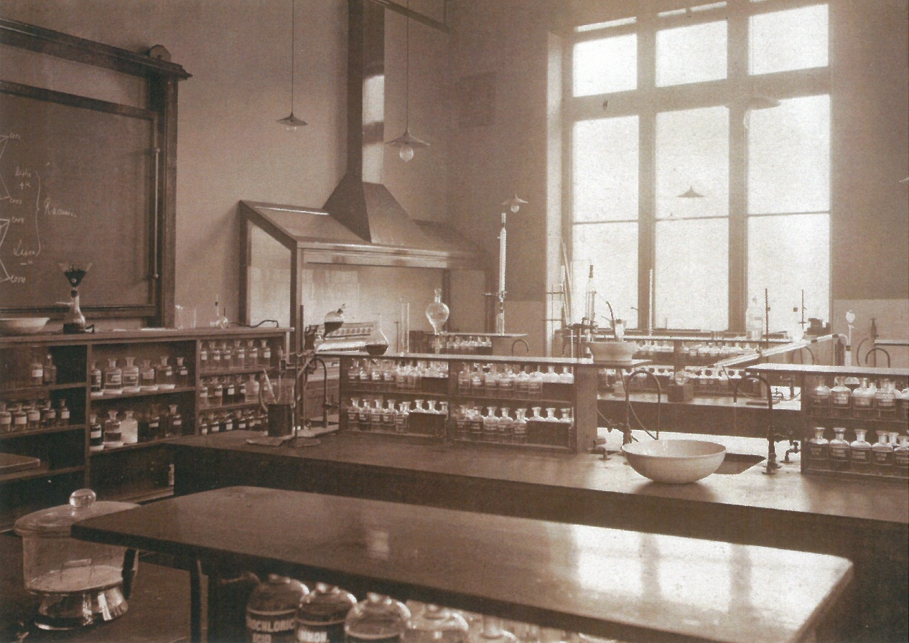

EDUCATION PACK

This pack accompanies the film “Education” which can be viewed online at www.heritagequay.org
February 2017
CONTENTS

INTRODUCTION

WATCHING THE FILM

ANSWERING THE QUESTIONS

POST FILM ACTIVITY SUGGESTIONS

FILM IMAGES

FILM SCRIPT

FURTHER LINKS AND RESOURCES

This work is licensed under a Creative Commons Attribution 4.0 International License
Images © as attributed
INTRODUCTION

This film and pack have been developed to introduce students to the history of the University of Huddersfield, reflecting as it does the industrial and philanthropic origins of many other universities in the U.K.
The archives contain many more collections than can be covered here and educators should refer to the online catalogues at www.heritagequay.org/ or contact Heritage Quay on 01484 473 168 or email archives@hud.ac.uk to find out more or book a visit.
This pack supports the following areas of the curriculum:
- KS1 Local History Study: “significant local events, people and places”
The university’s history can be part of a wider study of the Ramsden family and their signficant contribution to the growth of Huddersfield as a industrial town.
- KS2 Local History Study: “study of an aspect or theme in British history that extends pupils’ chronological knowledge beyond 1066”

- KS3 Local History Study: “a study over time, testing how far sites in their locality reflect aspects of national history”
The university has its beginnings in the philanthropy of a local businessman (Frederick Schwann), leading to the establishment of the Mechanics’ Institute and then the Huddersfield Female Educational Institute. This pattern reflects trends in the development of our national educational system, and provides a local exemplar for an important aspect of British History.
Pupils of all key stages would benefit from a visit to the unversity, including the Ramsden building and a campus tour, and possibly a workshop. Such a visit would raise aspirations for higher education as well as highlighting the role of the university in Huddersfield today.
WATCHING THE FILM
The film is intended as a starting point for a local history study at KS1/2. Two local history study options are suggested:
- The role of the Ramsden family in building the town of Huddersfield, including the University
- The history of the University, reflecting the development of British education since the mid 19th century, including women’s education
Visits (by arrangement) to the archives to view the collection first hand, or to the Ramsden building would be a valuable addition to either option.
It is suggested that teachers watch the film before showing it to students, and become familiar with the contents of this pack so that they are able to answer any questions. The film is 2 minutes 59 seconds long and includes a question focussing on the Ramsden family, known as the “family that shaped Huddersfield”.

2:13 The Ramsden family played an important role in the history of Huddersfield. Can you find their coat of arms in other buildings in the town?

ANSWERING THE QUESTION
An example of the Ramsden coat of arms can be seen on the Estate Buildings, Byram Arcade. Evidence of the Ramsden family can be found in street names as well as the coat of arms. As Lords of the Manor, they had control of naming the streets, many of which reflect their ownership of land in other parts of the country.
The 4 lions on the coats of arms seen on the Ramsden building, represent the Guild of Clothworkers, the town of Huddersfield, and the Brooke and Ramsden families. These two families were instrumental in the Technical Institute as it then was, being built.
Ramsden Street is named after the family, as is the Ramsden building (in the University).
John William Street is named after the 5th baronet, Sir John William Ramsden.
Dundas Street is named after Isabella Dundas, who was the mother of the 5th baronet.
The Huddersfield Canal was originally known as the Sir John Ramsden Canal.
Byram Street and Byram Arcade are named after Byram Hall, the Ramsden family’s country house near Pontefract.

POST FILM ACTIVITY SUGGESTIONS
A visit to the university is recommended. Pupils can attend a familiarisation day or take a campus tour led by a University student.
HUDDERSFIELD UNIVERSITY:
The archives contain many historic photographs of classrooms and reading rooms in the Ramsden building as well as floor plans. Pupils could:
- compare the photographs with the way today’s university classrooms look, or their own.
- re-create a Victorian reading room in the school library or their own classroom
- visit the Ramsden building, using the Heritage Quay sheet What Will You Discover? to investigate further. (see Links and Further Resources).
- build a model of the Ramsden building, using Lego or cardboard boxes
- design a university of the future
- visit Heritage Quay and study the university archives, find former students who became well known n their fields
In 1883, the Huddersfield Technical School (as it then was) held a Fine Art & Industrial Exhibition. The catalogue is held in the university archives and there are many photographs and news cuttings of the exhibition. Children could:
- investigate the kinds of subjects taught at a technical school, and why these might be needed in a town like Huddersfield
- contact the archives for an object handling session. Show children the art examination box and set them a similar task

BRITISH EDUCATION:
Use the billboard advertising subjects suitable for women to study, to:
- Open up a debate on equality of education and career choice, comparing careers open to women 100 years ago with those of today.
- Compile a list of the first women – first female M.P., prime minister, professional rugby player, airline pilot etc.
IMAGES
The images appearing in the film may be subject to copyright. They include items from the university archives. In order of appearance:

Ramsden building commemorative mug and bowl
Frederick Schwann, 1799 – 1882 , founder of the Yong Men’s Mental Improvement Society
Huddersfield Mechanics Institute in Northumberland Street
Plans of Huddersfield Mechanics Institute in Northumberland Street
Bell hung at the Huddersfield Mechanics Institute
Female Educational Institute curriculum
Ramsden building and plans
Ramsden building today, exterior and interior

The image on the cover of this pack is of a classroom in the Ramsden Building which housed the Huddersfield Mechanics Institute, and dates from the 1890s.

SCRIPT
The University of Huddersfield’s archives are based at Heritage Quay. They hold records that tell the story of the university’s history. In 1841 a group of five young working men approached their employer, a German born manufacturer called Frederick Schwann. They asked him to to support them in giving them money to help them get a better education. They formed a group called the Young Men’s Mental Improvement Society and this was the beginning of the university. Many of the town’s significant people taught classes, including Frederick Schwann and they had their own library. They also met socially for outings on the new railway and Christmas entertainments. The idea became so popular that by 1844 there were over 400 students, all men, who were attending classes in subjects like Chemistry, Maths, Engineering and French.
The Society’s name was changed to the Huddersfield Mechanics’ Institute and they moved to bigger premises several times as numbers increased.
This mug and bowl commemorated the opening of the Ramsden Building in 1884.
A bell was specially cast to hang in this building. It called the students to their classes.
Women could not attend classes at the Mechanics’ Institute, but in 1846, the Huddersfield Female Educational Institute was founded. It was one of the first Female Educational Institutes in the UK.
In 1883, the two organisations merged and moved to a brand new building named after the family from which the university bought the land, Sir John William Ramsden. In tribute, part of the family crest was incorporated into the building’s decoration.
This notice from the Huddersfield Female Educational Institute shows the subjects and timetable taught in 1882. Many of the subjects were considered suitable for girls, such as needlework or cookery, but girls also had the chance to learn geography and science.
Some people thought that men and women should not be taught the same subjects; others believed women should not be educated at all. Even when women were allowed to go to university, they were not always able to take their final exams.
- The Ramsden family played an important role in the history of Huddersfield. Can you find their coat of arms in other buildings in the town?

The Ramsden building is still part of the university today. The University was 175 years old in 2016 and now teaches subjects such as architecture, politics and forensic science. Men and women can study for a degree in any subject they choose.
What would you like to study at university? When you visit Heritage Quay, you can find out more about the university’s history and go on a campus tour, led by one of our students.

FURTHER LINKS AND RESOURCES
https://www.equalityhumanrights.com/en/lesson-activity-ideas a short film, information and lesson plans on teaching careers and equality at KS2
http://www.educationengland.org.uk/history/ the history of schools in England – key points including a time line – teacher resource
http://www.historyofeducation.org.uk/ information and key events
http://schools.keldysh.ru/school1413/eng/egorova_ks/str6.html
https://www.tes.com/news/school-news/breaking-news/timeline-a-history-education
“From Mechanics’ Institution to Polytechnic: further and higher education 1841-1970” by John O’Connell
Contact Heritage Quay for a university timeline
www.discoverhuddersfield.com – heritage trails
https://huddersfield.exposed/wiki/John_Frederic_Schwann_(c.1799-1882) Frederick Schwann biography

The Ramsden Building – What Will You Discover?

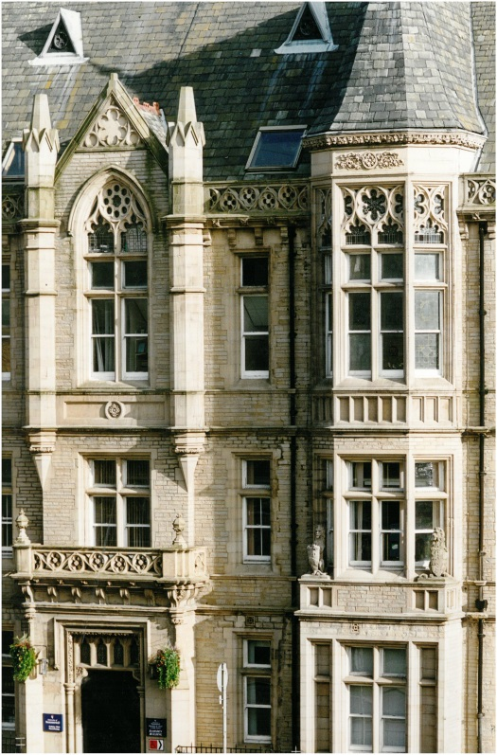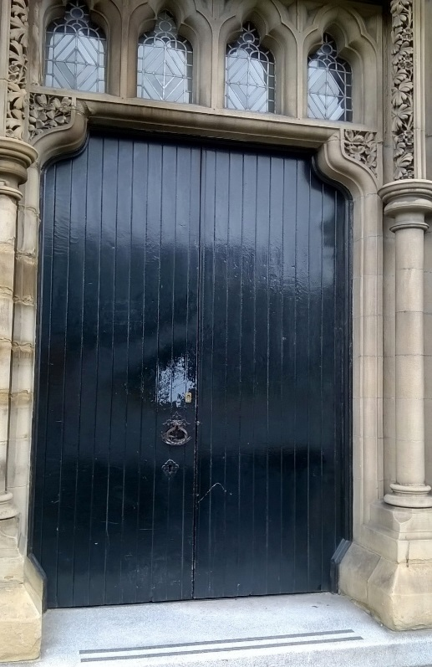

Outside – lots of decoration and detail tell you that this was an important building

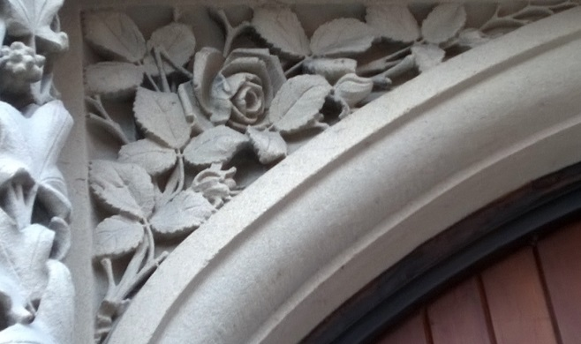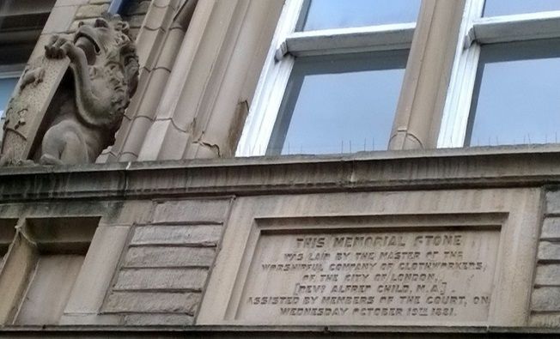
The Huddersfield Technical School and Mechanics Institute Building was opened in 1883 – can you find the date when building work began?

The Ramsden Building – What Will You Discover?

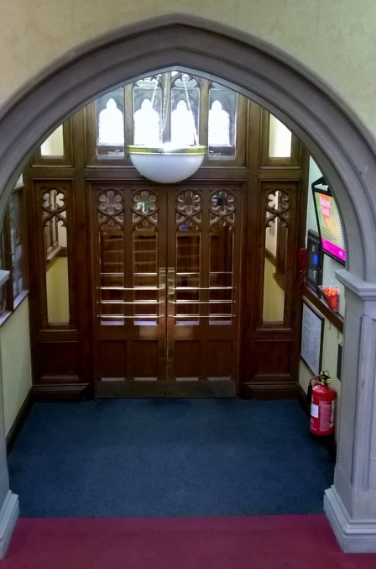
Inside is richly decorated too. What do you notice about the stained glass window half way up the grand staircase?
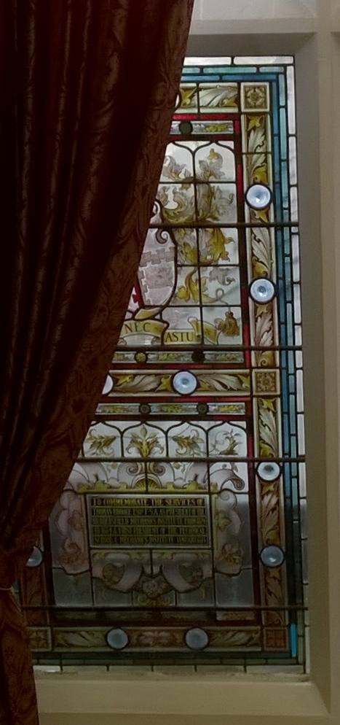
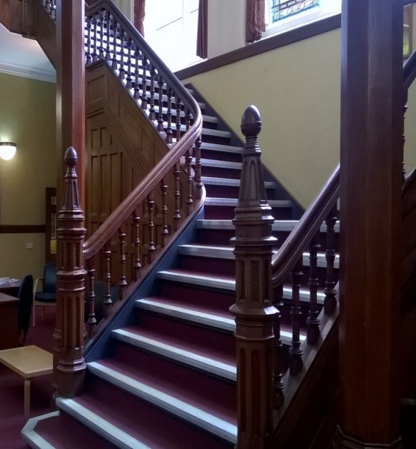
Turn left when you get to the top of the staircase. What do you see?
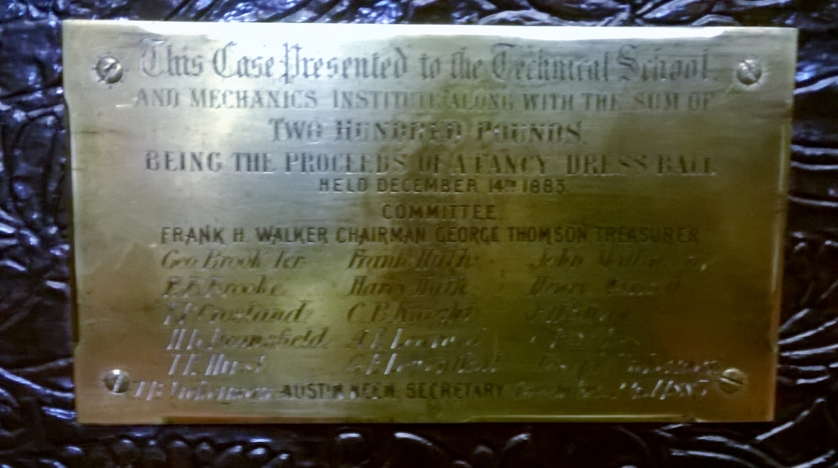
Can you find the display case with this plaque?
Can you find the display case with this plaque?
Turn left when you get to the top of the staircase. What do you see?

The Ramsden Building – The War Memorial

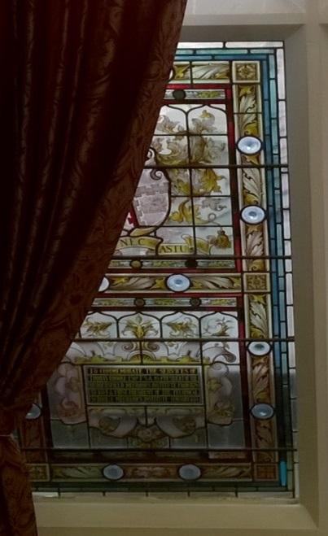
The War Memorial is on the landing at the top of the stairs.
It was painted in the 1920s by John Richardson Gault who was head of the University’s School of Art. The Vice Chancellor lays a wreath here every year on Remembrance Day
Inside is richly decorated too. Half way up the staircase is a stained glass window showing a coat of arms. These are the Brooke family arms (also found outside). Sir Thomas Brooke supported the construction of the Ramsden building.
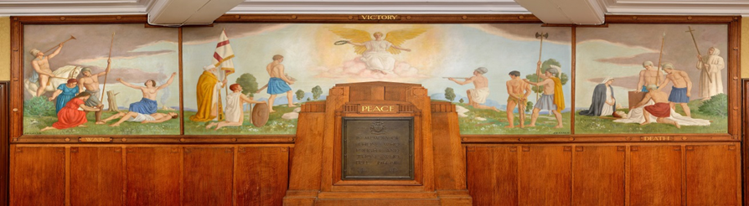
The painting is a triptych. This means it is in 3 parts or panels.
- Can you see where the panels join?
- What is at the centre of the painting?
- What is the angel holding? (laurel wreath symbolising victory and eternity)
The cypress trees symbolise death.
Now look at the bottom of the outside panels, and the top of the centre one. Can you see the words, War, Victory and Death?
- What else can you see in the painting?
- Does this painting remind you of anything else?

