Classroom Museum Acquisition and Storage Record
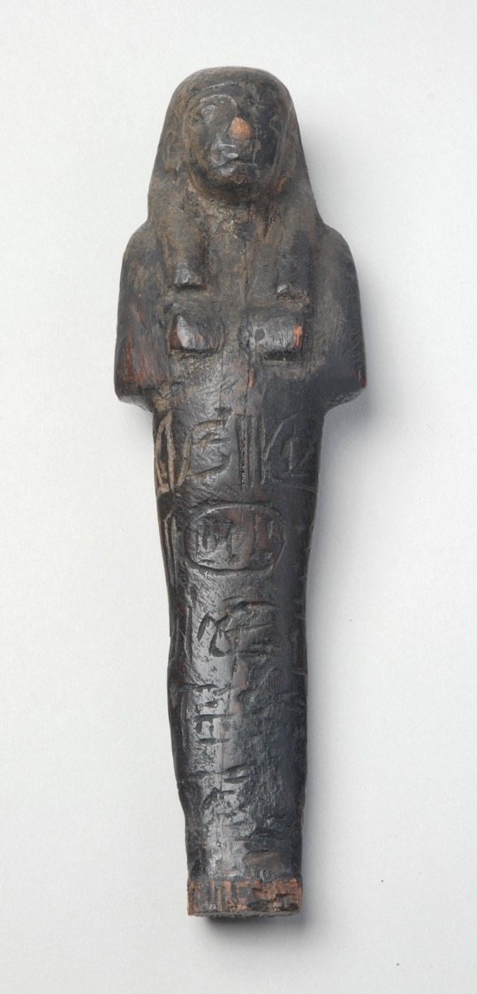
Department in the Museum: | Archaeology
Type of object: | Figurine
Full Name of object: | Shabti of Seti I
Origin date: | c.1289 BCE
Period in history: | Egyptian
Site where it was found: | Apis Room, Tomb of Seti I, The Valley of the Kings, Thebes, Egypt, North Africa, Africa
Materials it is made from: | Organic; wood; juniper wood
Full description of the object: | Wooden shabti with damaged nose. There are hieroglyphs down the front panel including a cartouche of Seti I. The shabti has a modern mahogany plinth on which is painted the wording 'Ushabti with the name of Seti I B.C. 1405'. Beneath the plinth is written in ink 'From Miss Amelia B. Edwards Westbury-on-Trym, December 29th. 1887.'
Dimensions: | object height: 200mm  object width (max): 57mm
Provenance: | Found in the 'Apis' Room' when opening the tomb of Sethos I (KV17) in 1817. It somehow became the property of Amelia Edwards, who donated it to Aquila Dodgson. Sarah Dodgson, wife of Aquila Dodgson, gave this object as part of a collection to E. Raymond Hepper of Leeds sometime before her death in 1951. E. Raymond Hepper bequeathed the Egyptian collection to his son, F. Nigel Hepper, on his death in 1970. F. Nigel Hepper sold this object to Leeds Museums and Galleries in 2004, at the same time as the 'Aquila Dodgson collection (LEEDM.D.2004.1).
Exhibition history: | 2008 - Ancient Worlds gallery, Leeds City Museum
Other: | Published references: Hepper, Nigel (2000) 'Amelia Edwards' Sethos I shabti' in The Journal of Egyptian Archaeology, Volume 86, pgs 165-166.

