So you think you can be a member of the GIS?
In 1941 Rose Kerr, International Commissioner, wrote a letter printed in ‘The Guider’ asking for “an army of peace” “… whatever happens, Europe will be left weak and exhausted and will need an army of peace – an army mostly composed of women… If we can begin now to collect our Army of Goodwill, what could they not do to bring healing and comfort to a stricken world”
Her efforts continued, and the following year the group was named ‘Guide International Service’ as it was simple, easily translated and understood in any language. There was a badge – of course - the gold trefoil from the World Flag with the letters GIS.
In December 1942, 153 Girl Guides, Rangers and Guiders, all aged 21 and above gathered for the first weekend training at Guide HQ.
As the GIS needed to be prepared to deal with the horrors of war, anyone who applied needed to have these qualities of character:
• Specialise in the impossible
• Be self-confident
• Have initiative
• Be possessed of dogged determination
• The ability to work in close co-operation
• Be adaptable to different cultures
• Resourcefulness to be prepared for unexpected responsibility • Able to cope with long periods of frustration
• Capable of living in each other’s pockets under difficult physical conditions
• Understand nature of work to be undertaken
• Sufficient steadfastness of purpose to carry on through day to-day hardship, strain and monotony
You may have already encountered and practiced many of these skills during the lockdown period we are experiencing in 2020 – do you think you would have been able to prove your resilience during World War 2? Take these tests and find out whether you would have been suitable to undertake the training.

Test 1: Kim’s Game
Have a look at the picture below for one minute, cover it up so you can no longer see it, and write all the items you can remember!
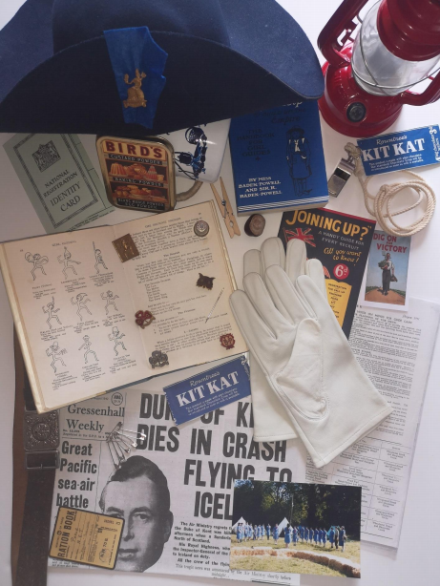

Part 2: For all recruits
- How many did you remember correctly?
- Are there any you do not recognise?
- How could you find out the name of those items unknown to you?
- Which item did you remember first?
- Does one item stand out to you – why?
  - Does it have a story behind it?
  - Explain in less than 50 words
Part 3: For those wishing to join officer training
- How many safety pins are there?
- What is the date of the newspaper and what is its name?
  - What is for supper on the Guide camp menu?
- In which edition of The Guider did it appear?
- Which camp staple is advertised?
- Is there anything out of place in this picture – give your reasoning behind your decision
Part 4: Challenge yourself
- Try again and see if you can better your score.
- Now prepare your own version of Kim’s Game and challenge your family and friends. Who can remember the most items successfully?
- Is there a knack, or a system, to remember as many of the items as possible? Can you share your system with us?

Test 2: Morse Code

Use the morse code key below to translate the following messages

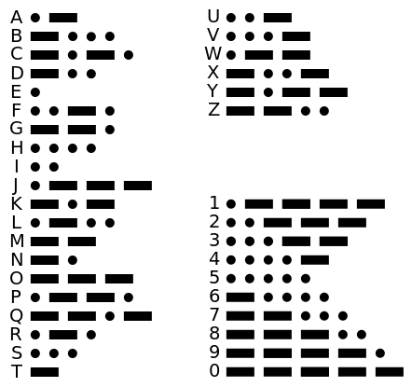

Use the Morse code key above to decode the following messages:

Message 1:
- .... .. ... / - . ... - / .-- .. .-.. .-.. / ... .... --- .-- / .... --- .-- / .-- . .-.. .-.. / -.-- --- ..- / -.- -. --- .-- / -.-- --- ..- .-. / -- --- .-. ... . / -.-. --- -.. . /

Message 2:
.. ..-. / -.-- --- ..- / .- .-. . / .- -... .-.. . / - --- / ..- -. -.. . .-. ... - .- -. -.. / - .... .. ... / -- . ... ... .- --. . / .--. --- ... - / .- -. / .- -. .. -- .- .-.. / --- ..-. / -.-- --- ..- .-. / -.-. .... --- .. -.-. . / .- ... / .- / -.-. --- --

Message 3:
-- . -. - / - --- / - .... . / ..-. .- -.-. . -... --- --- -.- / .--. --- ... - / ..-. --- .-. / - .... .. ... / - .- ... -.- /

Message 4:
.-- .... .- - / .- -. .. -- .- .-.. / -.. --- / -.-- --- ..- / - .... .. -. -.- / .-- .. .-.. .-.. / -... . / -- --- ... - / .--. --- .--. ..- .-.. .- .-.

Test 3: Code breaking (Part 1)
Although your mission will be strictly of a non-military nature, there may be occasions when you need to read or send a confidential message.
Example 1:
IKTN IWKFG
Can you read these two words? Hint – many young people are one of these.

The message is GIRL GUIDE – each letter has been substituted for the one two places along in the alphabet. So…
VTA AQWT QYP EQFG
Example 2:
This one is more difficult! Each symbol has a numerical value (each is different and ranges from 1 to 9) Solve the puzzles to work out the value of each symbol.

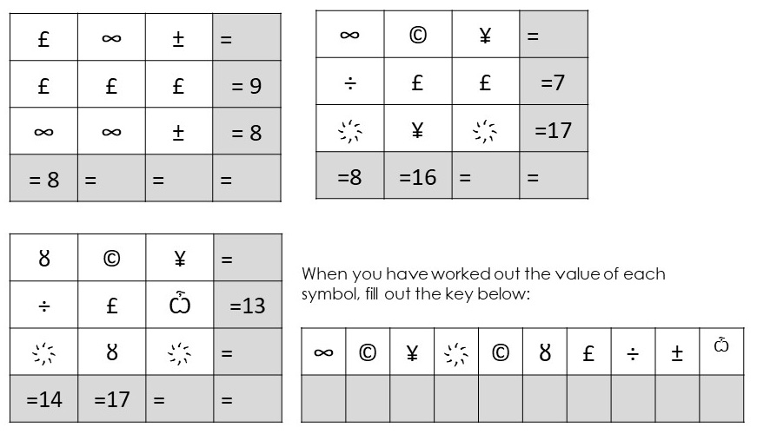

Code breaking (Part 2):

Now you need to work out your alphabet code – fill in the blanks (use logic, it is that simple)

A | B | C | D | E | F | G | H | I | J
1 |  |  |  |  |  |  | 8

K | L | M | N | O | P | Q | R | S | T
11 |  | 13

U | V | W | X | Y | Z
 | 22 |  |  |  | 26

Code breaking (Part 3):
Add together each column, and the total will give you a letter according to the grid above… If the answer is a mystery, do some research or ask a friend!

÷ | ± | ¥ | ҉ | Ѽ
 | £ | ¥ |  | ȣ
 |  |  |  | ∞

∞ | ÷ | ± | ҉ | ©
 |  |  |  | ȣ

¥ | Ѽ | Ѽ | ÷ | © | £
± | ҉ | ȣ | ± | © | ¥
҉ | ÷ | © |  |  | ∞

Test 4: Observation
Solve the wordsearch to find countries you may need to visit (if you are successfully trained to join the GIS) and there is one extra answer – it is vital to our success

S | A | L | U | T | E | S | I | G | N | G
F | C | D | E | C | A | L | P | S | I | D
R | T | R | E | E | K | E | R | R | C | E
I | I | G | I | S | E | G | B | O | A | T
E | O | Y | T | E | A | M | P | S | T | R
N | N | N | G | B | E | R | M | E | P | U
D | E | R | A | N | I | Y | H | O | E | C
T | R | E | F | O | I | L | L | L | A | K
H | K | L | A | N | R | D | L | S | C | U
E | E | I | E | G | D | A | B | Y | E | M
L | R | E | D | A | I | W | O | R | K | A
P | T | F | I | L | A | R | L | I | O | T
S | C | O | U | T | Y | A | L | K | I | T
A | I | D | G | E | S | I | M | O | R | P

ROSE PROMISE ACTION BILLY OAR KERR DISPLACED TRUCK TENT GIS PEACE SALUTE TREK TOIL SEA TREFOIL FRIEND WORK SIGN AID BADGE RELIEF BOAT TEAM KIT GIRL SCOUT GUIDE HELP
Test 5: Finances
How well do you know your money? Can you name these coins? Use research skills to find out what each of these coins are worth in today’s money. How do they relate to each other?
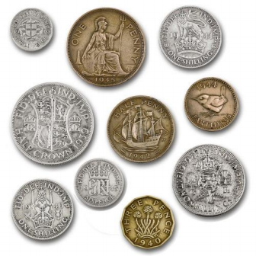
You are sent for basic provisions – how much did your shop cost in 1945, and how much will it cost today? Use the historical currency converter to find out!

 | 1945 price | Today’s price
Loaf of bread
Pint of milk
Sugar
Eggs
Tea
Tin of Spam
Chocolate

Self Evaluation

Did you enjoy the initiative tests?

Have you completed all 5 tasks?

If not, why?

Are you able to say you did your best for each and every one?

What was the biggest challenge?

Which task was most difficult? Why?

Have you found out anything about yourself whilst doing these tasks?

Is it something that you can use in the future and if so, how?

