Havercake Recipe
Ingredients
- 6 oz fine or medium oatmeal
- A pinch of salt
- A pinch of bicarbonate of soda
- 2 oz flour
- Boiling water (caution needed with younger children)
- One tablespoon melted dripping or butter

Method
- Mix together the dry ingredients and add fat with enough boiling water to make a pliable dough.
- Knead well and roll out thinly.
- Pre-heat the oven to 350°F, 180°C or gas mark 4.
- Cut into rounds or triangles and bake until brown and crisp, about 25 minutes
- Serve buttered and with cheese or preserves.

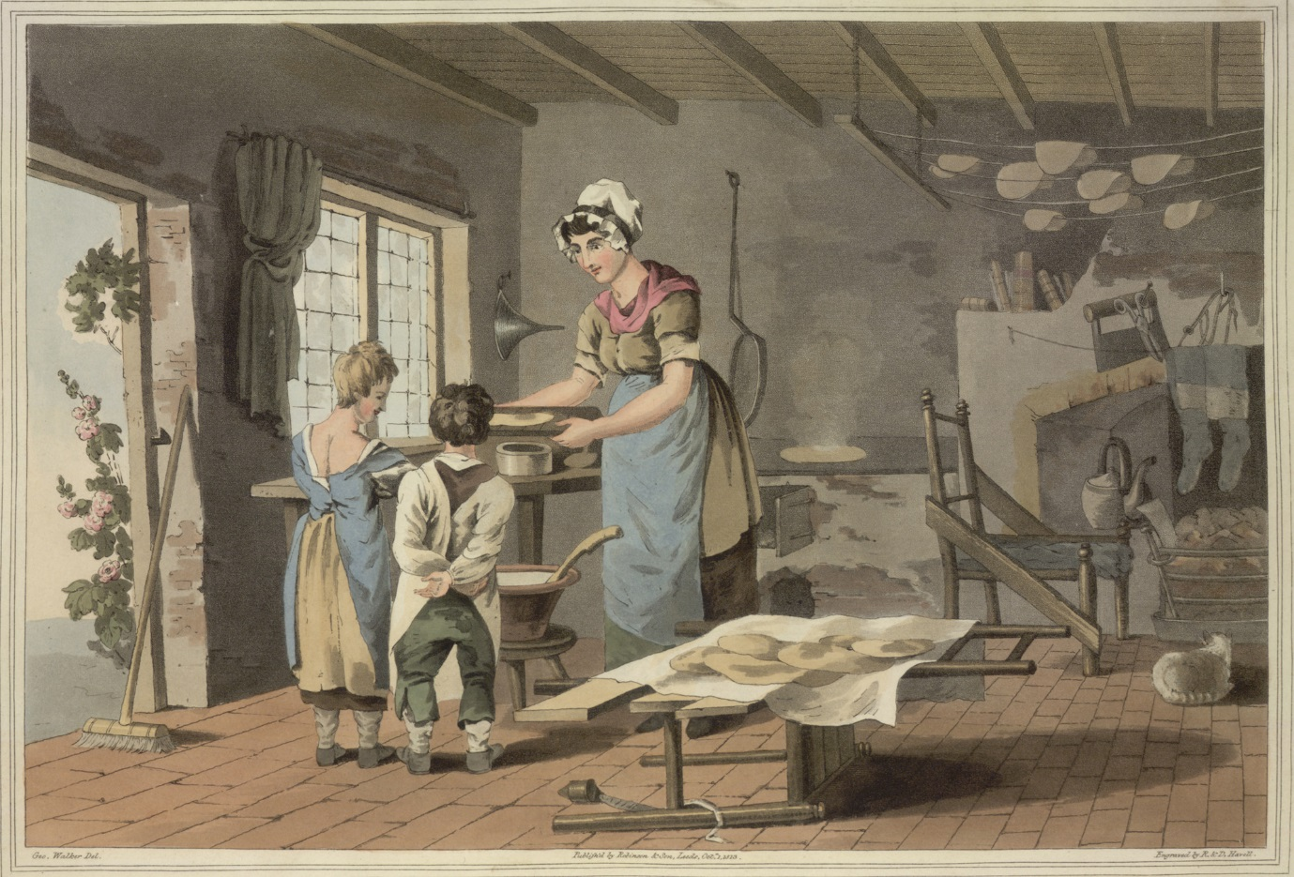

Illustration from George Walker’s ‘The Costume of Yorkshire’ published in 1814. A havercake can be seen cooking on the grill, with others drying from a rack on the ceiling above the fire. Image: Public Domain

