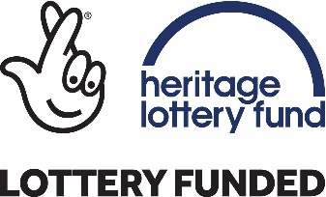

THE ARTS
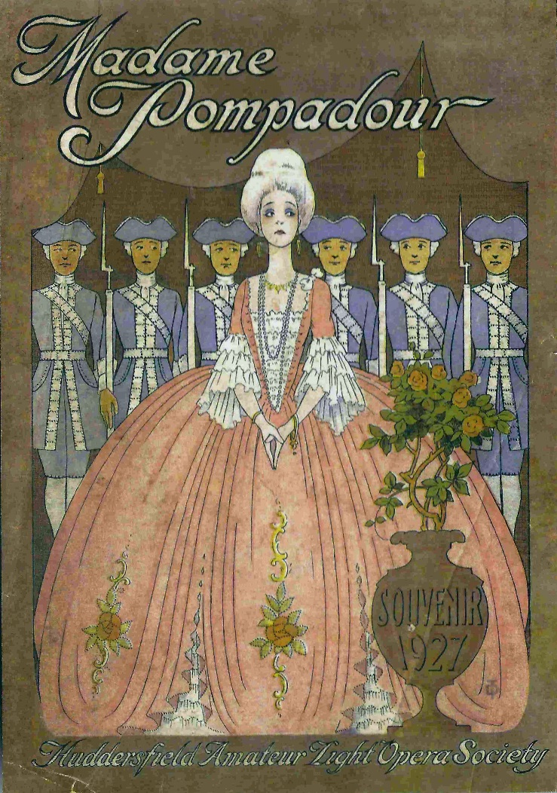

EDUCATION PACK

This pack accompanies the film “The Arts” which can be viewed online at www.heritagequay.org
February 2017

CONTENTS

INTRODUCTION

WATCHING THE FILM

ANSWERING THE QUESTIONS

POST FILM ACTIVITY SUGGESTIONS

FILM IMAGES

FILM SCRIPT

FURTHER LINKS AND RESOURCES

This work is licensed under a Creative Commons Attribution 4.0 International License
Images © as attributed

INTRODUCTION

This film and pack have been developed to introduce students to the arts collections in the University of Huddersfield’s archives.
The archives contain collections which reflect the range of human creative expression, from the visual arts reflected in the Huddersfield Fine Art and Industrial Exhibition, to performance arts portrayed by local drama and musical groups such as the Huddersfield Amateur Operatic Society and the Lawrence Batley and Mikron theatres. More details are found in the online catalogues at www.heritagequay.org or you can contact Heritage Quay on 01484 473 168 or email archives@hud.ac.uk to find out more or book a visit.
This pack supports the following areas of the curriculum:

- KS3 HISTORY: “the development of society in Britain 1509 – 1745, e.g society and culture including theatre, art and music”

The film and pack provide an engaging starting point for studying the development of British theatre through Huddersfield professional and amateur drama companies. Students can also study the history of former theatre buildings in Huddersfield, where they were and how they are used now.

WATCHING THE FILM
The film gives an outline of the development of British theatre. At local level, the focus is on three diverse local professional and amateur theatre companies, and provides a starting point for research into Huddersfield’s historic theatre buildings.
It is suggested that teachers watch the film before showing it to students, and become familiar with the contents of this pack so that they are able to answer any questions.
The film is 3 minutes 13 seconds long and includes stopping points with questions which are listed below. These can be used as a starting point for classroom activities or a way of finding out what students already know.
The questions are as follows:
1:48 What can you discover about theatres 500 years ago? How are they different from theatres of today?
1:56 Can you find out about other buildings which were converted to theatres? What happened to them after the theatres closed?

ANSWERING THE QUESTIONS
What can you discover about theatres 500 years ago? How are they different
from theatres of today?

Early theatre was religious theatre. During medieval times, the church used miracle
plays and religious stories as a means of control and distraction. Early plays took
the form of mystery cycles which dramatized Bible stories, and the lives of saints
were portrayed in miracle stories. In this way, moral messages were disseminated
throughout society. Gradually the idea of organised performance took hold and this
developed into the theatre of today.

Performances took place on pageant wagons in town squares or church grounds.
The wagons comprised a stage, sometimes with two levels. The wagons processed
through the streets and from village to village, stopping at pre-arranged sites to
perform. In some towns, stages or scaffolds were fixed to allow a permanent staging
area. (See the BBC and VAM websites in Further Links and Resources).

Religious theatre was banned by Henry VIII for fear of spreading the Catholic faith.
Entertainment at court was important however, and small companies of actors
sprang up, who performed in royal and aristocratic households. The King could
grant these companies a licence to perform in public as well, if they were sponsored
by a nobleman. The first public performances often took place in enclosed spaces,
such as the courtyards of public houses. In the mid-16th century, purpose built
theatres began to appear. Most were circular in design with an open courtyard and
the audience stood on three sides of the stage.

Fully enclosed theatres followed, and these were known as private theatres
because they were indoors. The public could attend the performances in private
theatres but they were more expensive and attracted a more sophisticated audience.

Can you find out about other buildings which were converted to theatres?
What happened to them after the theatres closed?

This question directs students to consider theatres in Huddersfield, of which there
were many in the 19th and 20th centuries. This website contains a wealth of
information about former theatre buildings in Huddersfield
http://www.arthurlloyd.co.uk/HuddersfieldTheatres.htm#royal.
The buildings have been used variously as a riding stables, cinema, pubs, and a
night club on the site of the new market hall. In the case of the riding stables, the
original use can still be discerned from the stone relief of a horse above its entrance
(the former Hippodrome , opposite the University). The website also gives details of
some of the performers who appeared at the theatres.

POST FILM ACTIVITY SUGGESTIONS
The study of British theatre lends itself to the Arts Award scheme which has many ideas for developing arts based activities to explore history. See Further Links and Resources for details of the scheme. Students could:
- Create a 3D model of a pageant wagon, public courtyard, and enclosed private theatre

- Create a timeline of the key events and personalities in the history of British theatre. This could be presented as a performance.

- Use items from the arts collections in Heritage Quay to inspire drawings, collage, sculpture

- Research the life of a local theatre and show the changes of use and in the building

- Visit the sites of former theatres in Huddersfield

- Take a tour of the Lawrence Batley theatre or participate in one of their school workshops/projects

- See a live dance, drama or musical performance by a local theatre company

IMAGES
The images appearing in the film may be subject to copyright. They include items from the Lawrence Batley and Mikron theatre collections, and the Huddersfield Amateur Operatic Society. In order of appearance:
Commemmorative and officials’ ribbons from the HAOS
Dolls representing characters from operas performed by HAOS early 20th century
HAOS dance troupe
Lawrence Batley Theatre, formerly a chapel
Travelling players
Booth type stage from 1542
Shakespearean theatre – The Swan
The Haymarket Opera House or Kings Theatre, Haymarket, London built 1704
Programmes and promotional material for the Mikron Theatre Company
HAOS performance
Programme for the Theatre Royal, Huddersfield, demolished 1961

The image on the cover of this pack is an advertisement for the 1927 production of Madame Pompadour, performed by the Huddersfield Amateur Light Operatic Society .

SCRIPT
Welcome to the University of Huddersfield’s archives at Heritage Quay. This film is about our Arts collections. Huddersfield has always had a lively arts scene, with lots of opportunities to participate in dance, music, theatre and opera. 150 years ago there were at least twelve theatre venues in the town. Today Huddersfield’s Lawrence Batley theatre hosts arts events from national and international performers.
This picture of the Lawrence Batley theatre doesn’t look much like a theatre, because the building started life as a chapel. It was converted to a theatre in 1994.
1000 years ago, plays were performed out of doors. They weren’t like the plays of today. Sometimes actors would make a stage on the back of a wagon, and travel around to find new audiences. Gradually, plays started to move under cover – often in enclosed courtyards. 500 years ago, the first purpose built theatres appeared. These were called private theatres and needed a licence from the King to operate.
Do you remember what I said about travelling theatre – where the actors took the play to new audiences on the back of a wagon? Huddersfield has a travelling theatre nowadays. But this theatre doesn’t use a horse and cart– it travels all over England by canal.
It’s called the Mikron Theatre and this is a programme from one of their shows. Mikron write the plays themselves about subjects that are important to local people.
- What can you discover about theatres 500 years ago? How are they different from theatres of today?
- Can you find out about other buildings which were converted to theatres? What happened to them after the theatres closed?
The Mikron and Lawrence Batley are professional theatres. This means the actors are paid. There’s another kind of theatre where the actors aren’t paid. They just love to be involved. This is called amateur theatre.
These items are from the Huddersfield Amateur Operatic Society, which was founded in 1897 and is still going strong 120 years later under a new name. In operas, the story is told through singing. The dolls are replicas of the characters from the operas. The badges were worn by theatre officials and they commemorate the year when the operas were performed.
You can find out lots more about Huddersfield’s professional and amateur arts scene at Heritage Quay.

FURTHER LINKS AND RESOURCES

BRITISH THEATRE:
www.bbc.co.uk/timelines/zwx9j6f Break a Leg - the history of British theatre
www.vam.ac.uk/content/articles/e/early-british-theatre/ Victoria & Albert
Museum, many resources and information

www.thefinertimes.com/Middle-Ages/theatre-in-the-middle-ages.html Finer
Times detailed account of theatre in the Middle Ages

https://prezi.com/e1cpzhdmi2df/medieval-theatre-religious-plays-and-traveling
players/ student presentation on Medieval Theatre

www.theguardian.com/stage/2014/jun/12/medieval-theatre-shakespeare-carl
heap Guardian article on 21st century medieval companies

www.shakespearesglobe.com/education?gclid=CNCfpe3x_tECFfcK0wodRiIJiw
Shakespeare’s Globe teacher resources and activity suggestions

http://www.bristol.ac.uk/theatre-collection/
an extensive archive of theatre, with many online resources
www.artsaward.org.uk nationally recognised qualifications managed by Trinity
College, London

LOCAL THEATRE:
www.arthurlloyd.co.uk/HuddersfieldTheatres.htm#royal comprehensive history of theatres in Huddersfield
www.mikron.org.uk/ canal based travelling Mikron Theatre Company
http://thelbt.org/ Lawrence Batley Theatre
http://satellitearts.org.uk/ Satellite Arts theatre workshops
www.choltheatre.co.uk/ Chol Theatre – professional community theatre company

