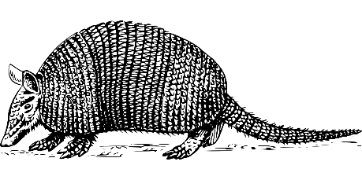
Identifying a Species Quiz

Work out which animal species is which by translating its Latin / Greek binomial name into English.
Draw a line from each translation to the correct English name. The first one is done for you.
Binomial Name | Translation |  | English Name
Canis lupus | “dog wolf” |  | Narwhal
Ornithorhynchus anatinus |  |  | Hippopotamus
Coccinella septempunctata |  |  | Long-tailed Tit
Passer domesticus |  |  | Grey Wolf
Aegithalos caudatus |  |  | Duck-billed Platypus
Dasypus novemcinctus |  |  | Nine-banded Armadillo
Monodon monoceros |  |  | Seven-spotted Ladybird
Hippopotamus amphibius |  |  | House Sparrow

Glossary:
aegithalos = titmouse | amphibius = water dwelling | anatinus = like a duck
canis = dog | caudatus = long-tailed | caudatus = long-tailed
ceros = horn | cinctus = circled | coccinus = scarlet
dasy = rough | domesticus = domestic | don = tooth
hippo = horse | lupus = wolf | mono = one
novem = nine | ornith = bird | passer = sparrow
potamus = river | punctate = dot/spot | pus = foot
rhynchus = nose/snout | septem = seven

