Joseph Briggs

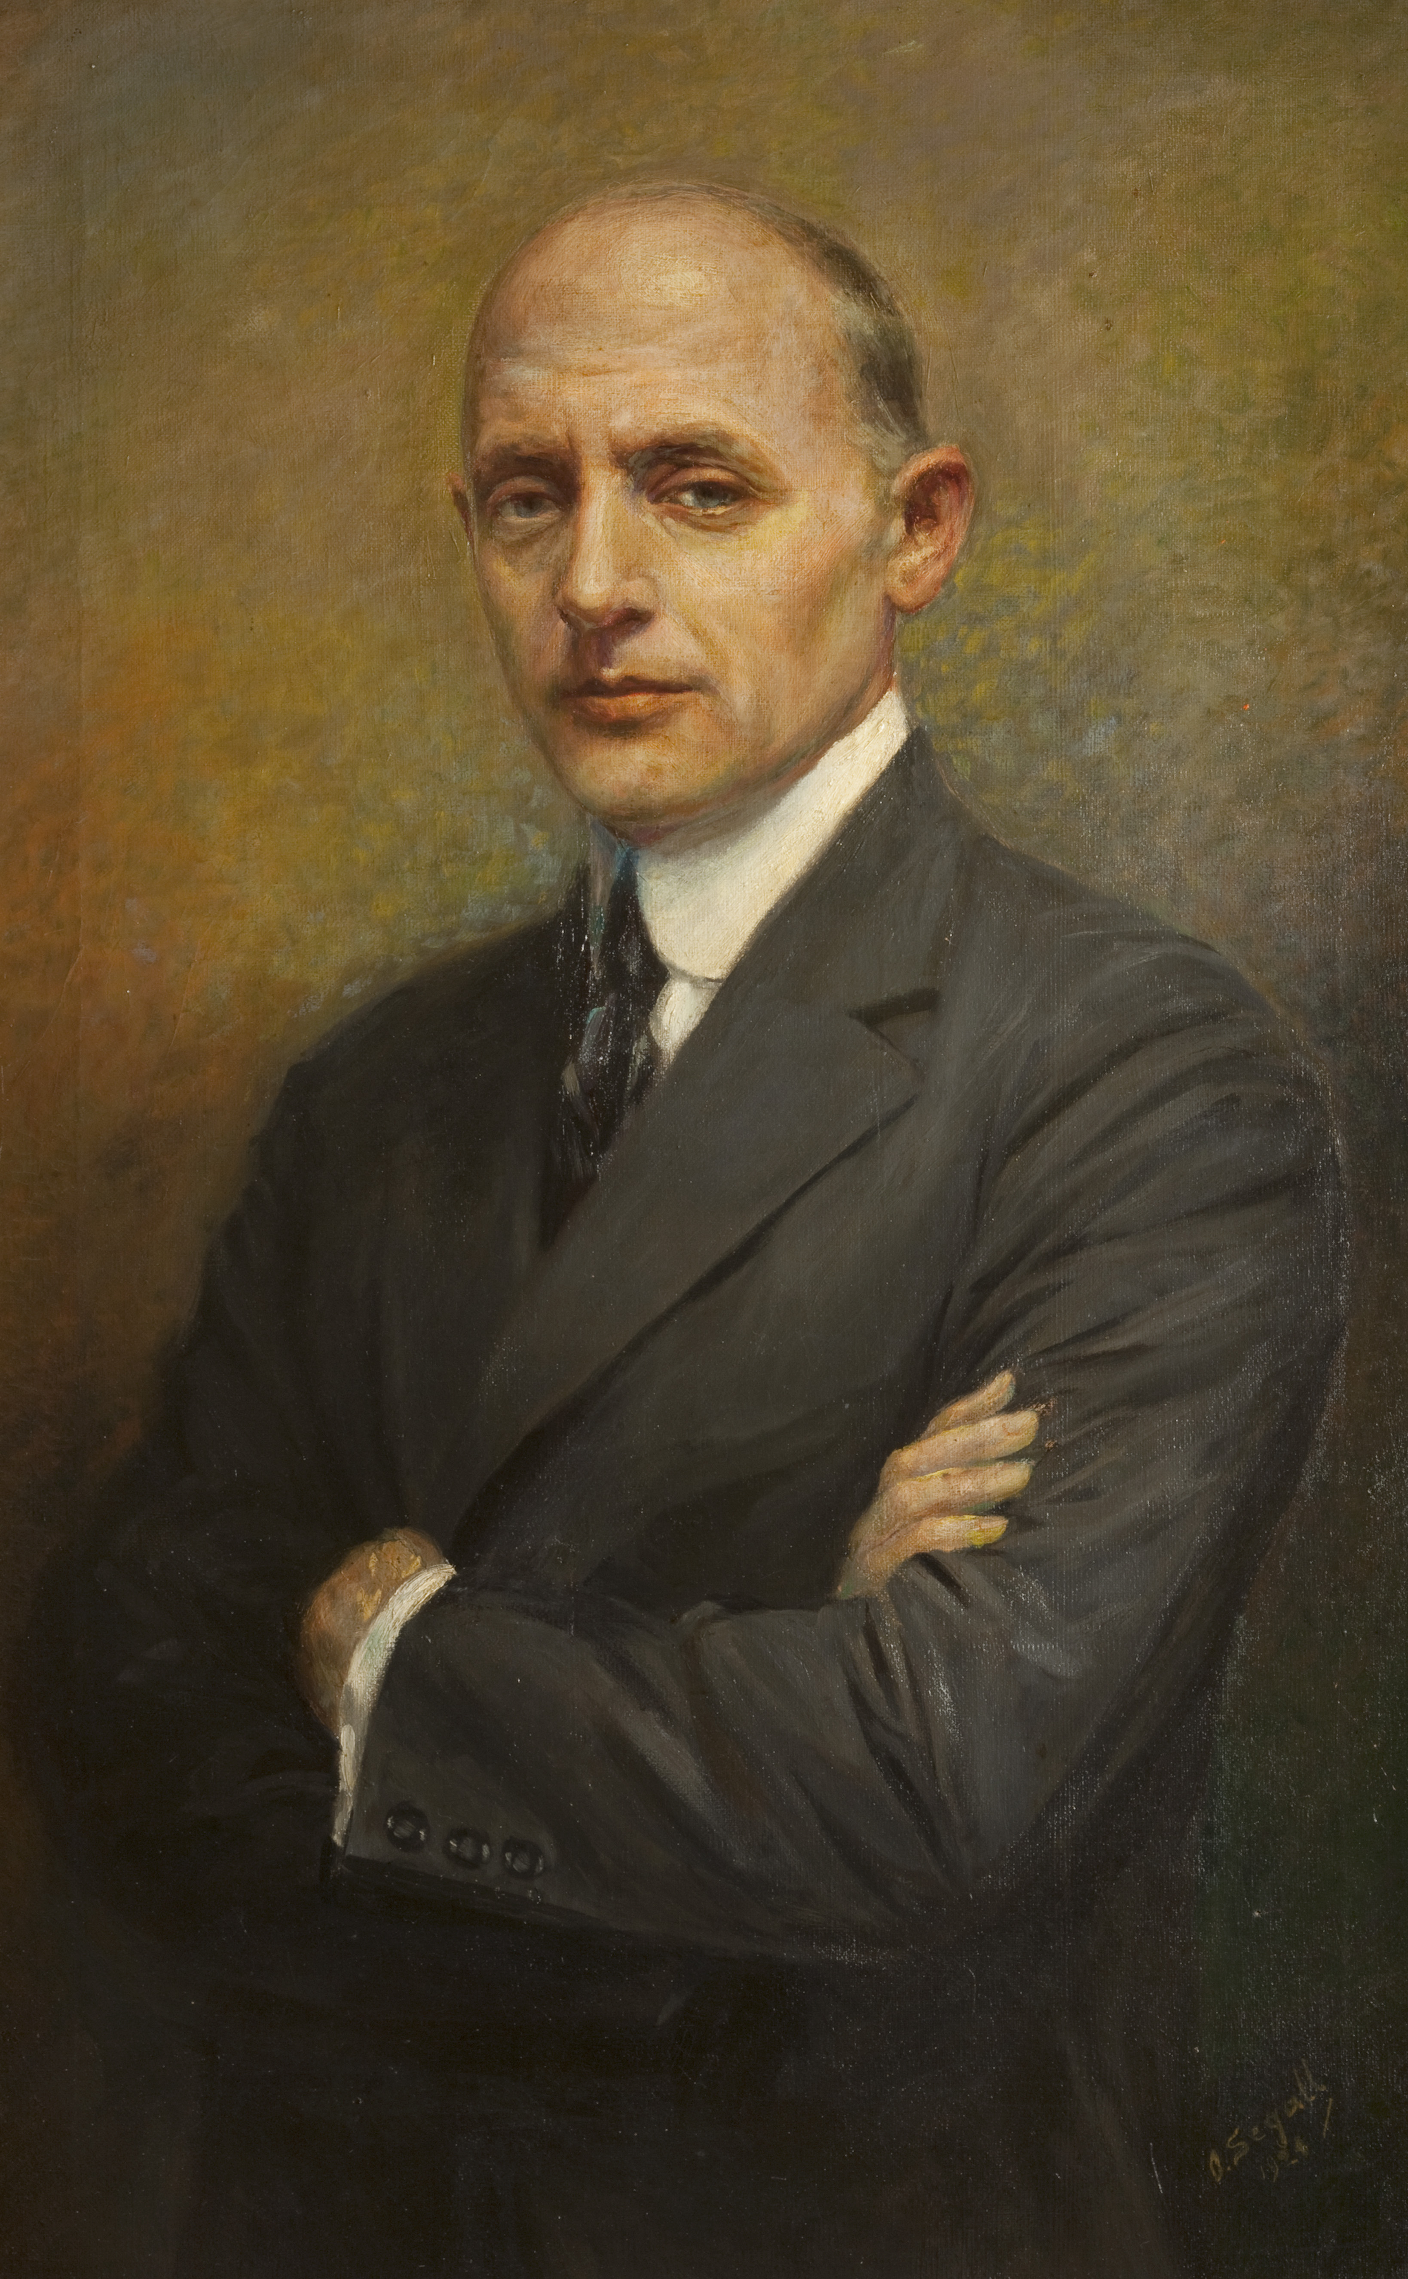
My name is Joseph Briggs. This is me aged about 51 years old.

I was born on 11 December 1873 at 3 Milnshaw Lane, Accrington, under the viaduct. My house was where the big roundabout is now.

My father was called Joseph too. He worked at Steiner’s Calico Printworks in Church.

Calico is a rough kind of cotton fabric. Frederick Steiner found a way of fixing dyes so that the colours didn’t run and opened a factory to print designs onto calico.
O. Segall 1924

My father worked as an engraver, helping to make patterns which were printed on the calico in different colours. There were lots of textile printing factories in Accrington and Steiner’s was one of the biggest in the whole country.

My father owned shares in the company as well as being an employee. He was a wealthy man – he owned 4 houses in Milnshaw Lane!

When I was about 12 I went to Accrington Mechanics Institution in St. James’ Street, where the Library is now. I learned science, maths and drawing because these skills were very important to the textiles industry.

When I was 14 I went to work at Steiner’s as an apprentice engraver, just like my dad. My two older brothers were already working there. I used my drawing skills to engrave the designs onto wooden blocks and metal rollers. I used my science skills to understand how the dyes were mixed and fixed. The colours had to match perfectly.

When I was nearly 18, I decided to go to America to seek my fortune. I travelled on a ship called the S.S. Servia and arrived after eight days’ voyage in New York on 21 September 1891.

It took a long time to get through the immigration process and I was so tired I went to the nearest boarding house. I met a man there who was a Pony Express rider in a Wild West show! His name was Seth Hathaway. He was the first friend I made in America and we would remain friends all our lives.

Seth also got me my first job in the Wild West show. As well as stunt riders, the show employed cowboys who could do shooting tricks. It was my job to hold the playing cards for them to shoot out of my hand!

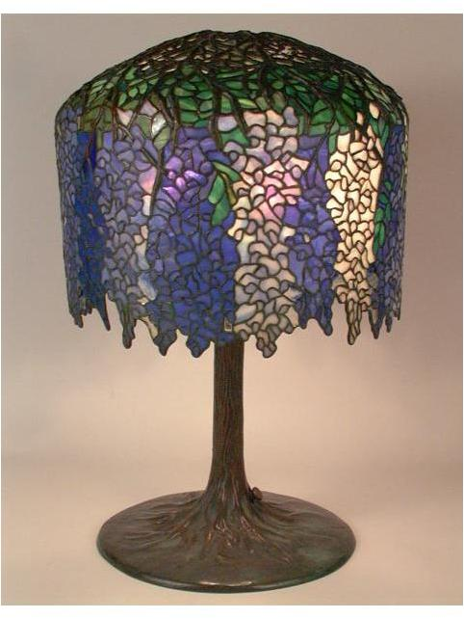
I stayed with the Wild West show for two years. The show toured across America, and I had many adventures on my travels and saw many wonderful things.

But the things that stood out in my memory were beautiful mosaic stained-glass vases and lamps made by a company called the Tiffany Glass and Decorating Company. These beautiful objects were made from a special kind of glass called favrile.

The colours and patterns reminded me of the beautiful designs I’d helped to create at Steiner’s Printworks in Accrington. I realised how much I missed creating beautiful things.

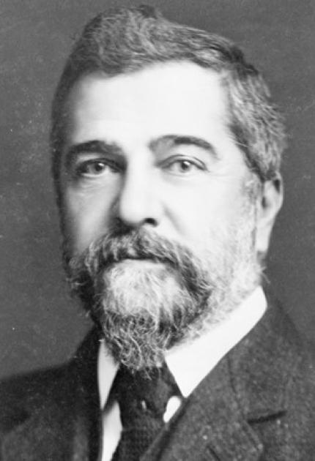
I applied several times for a job at Tiffany’s but without success. Then one day I bumped into Mr. Tiffany himself outside his offices! I begged him to let me show what I could do.

He agreed to give me a chance if I passed a drawing test! Even though I was a bit out of practice, I knew I was a good artist. Fortunately Mr. Tiffany thought so too and he gave me a job.

I began as an errand boy – I had to start at the bottom and prove myself. I knew if I worked hard and showed Mr. Tiffany what I could do, I would soon be creating beautiful glass lamps and vases myself.

After a while Mr. Tiffany decided I could learn how to make stained glass and soon I became head of the mosaic department. He even appointed me his personal assistant.

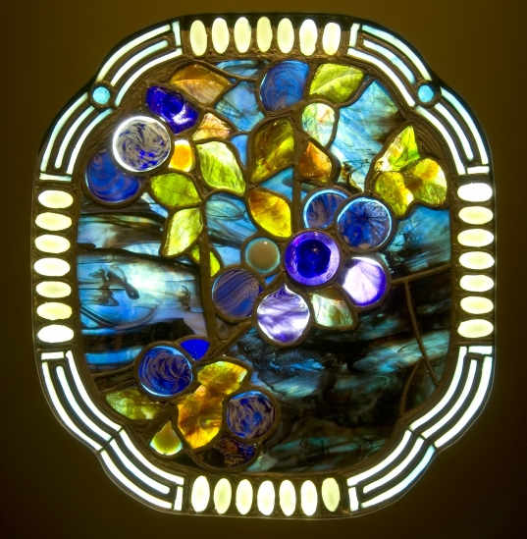

I invented new techniques for creating gorgeous colours and glass. I designed not only vases and lamps, but huge stained-glass mosaics for cathedrals, theatres and private houses. Tiffany Glass became famous the world over and we became very wealthy.

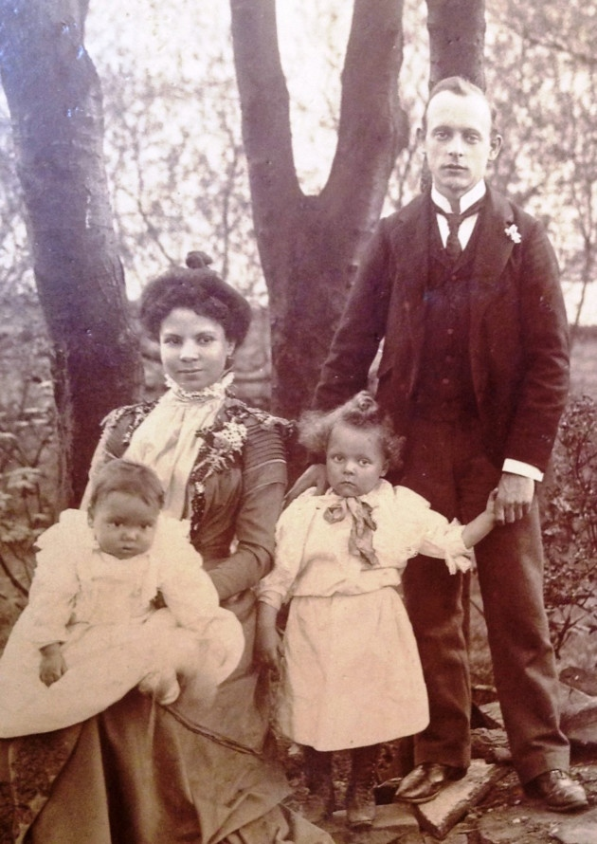
I was truly settled in America now. When I was 25 I married a lady called Elizabeth. Two years later we visited Accrington.
I wanted to show her the town where I had been born and learned my craft.

It was the only time I ever returned. When I was 33 I became an American citizen. I was a wealthy man now and had a house built for my wife and children, decorating it with many beautiful pieces of Tiffany glass like this stained-glass window.

When I was 46 Mr. Tiffany retired and left me the Tiffany Studios company so I could continue making the beautiful mosaic glass windows and lamps. But people no longer wanted to buy them. They thought the stained-glass mosaics were old fashioned. After a few years, the company went out of business.

But we still had lots of beautiful glass vases and lamps left and we didn’t know what to do with them. Many things were broken up and thrown into the river and rubbish tip. It broke my heart to see such beautiful things destroyed. I believed that one day people would want to see them again and I wanted to keep them safe until then.

I came up with the idea of sending them back to Accrington – back to the place where I had learned the skills which had helped to create them.

Before WW2 Accrington had a museum in Oak Hill Park, in what is now the Abbeyfield Home. I sent armfuls of pieces of Tiffany Glass to the museum and there they stayed for thirty years, packed away safely in their crates.

Many years later, in 1976, the Haworth Art Gallery unpacked the pieces and put them on display where they remain to this day – the largest collection of Tiffany Glass in Europe. I always knew that see such beautiful objects could not be hidden for ever.
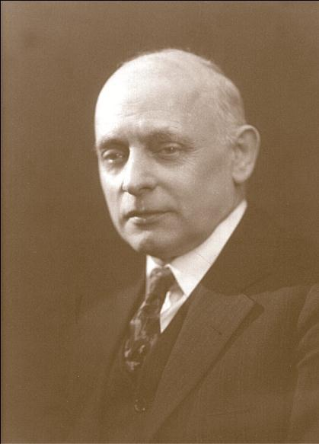
QUESTIONS FOR UNDERSTANDING
Remember to answer in full sentences.

- Where was Joseph born? What is there now?

- Was Joseph’s family well-off? Give reasons for your answer.

- What did Joseph’s dad do?

- What skills did Joseph learn at the Mechanics’ Institute?

- How long did Joseph stay at Steiners and what did he do when left?

- Why do you think Joseph left Steiners?

- How do you think the things Joseph had learned in Accrington helped him in his new life?

- Why do you think Joseph brought Elizabeth and his children to visit Accrington?

- Why do you think Joseph sent the Tiffany glass back to Accrington?

- What would you have done to save the Tiffany glass?

RESEARCH ACTIVITY

After WW1, Tiffany vases and lamps went out of fashion.

Look for pictures of other lamps and vases from 1919-1930 and put them into a sketch book with pictures of things made by Tiffany. Remember to label them with the date and maker’s name.

How are they different? Which do you prefer? Why?

