Leeds Memories in Sound

This resource was created using archives from the British Library.
NOTE: These activities use images and a powerpoint attached to this Learning Story on MyLearning. Please visit the Resources page to view and download these resources.

Theme/Enquiry Question and background notes

In the resources page you will find recordings of older people, and children from local schools in Quarry Street and Quarry Bank from the 1970s singing rhymes and talking about their memories. The recordings will help your students understand what life was like in the 1970s and explore working class life experiences in the 1920s and 1930s as recalled by Ivy Murray and Roland Kellet, two of the interviewees.
There are numerous opportunities to develop children’s questioning skills and historical thinking by making judgements from the evidence provided. Ivy talks about her life and community in Hunslet and Roland sings about the Barnbow Lasses, famous for working at the Barnbow munitions site during the First World War. There are opportunities to build a scheme of work around this topic as well as finding out more about where playground songs come from and whether they are the same now as they were then.

Note: Talking about childhood memories may be triggering for some children. Please take care to consider vulnerable children and have plans in place to support unexpected responses.

Curriculum Links

- KS1 History: Significant local historical events, people and places

- KS2 History: Theme extending knowledge beyond 1066

- KS2 Geography: Locational knowledge, geographical skills

- KS1 & KS2 English: Spoken language, reading & writing (persuasive language, tone, inference, slang, reading, listening etc.)

- KS2 Music: Pupils should be taught to: play and perform in solo and ensemble contexts, using their voices and playing musical instruments with increasing accuracy, fluency, control and expression. Improvise and compose music for a range of purposes using the inter-related dimensions of music and listen with attention to detail and recall sounds with increasing aural memory.

Activity Ideas

1.The Barnbow Lasses – what role did women play in the First World War?

Listen to the audio recordings of Roland Kellet, made in the 1970s. Roland sings a song about the Barnbow Lasses who worked in the Barnbow munitions factory in Leeds during the First World War.

This PowerPoint lesson plan uses primary evidence, in the form of audio and images, to support students’ learning. The PowerPoint includes an exploration of the context and need for a new munitions factory in Leeds and the lives of the women working there. There is a quiz and suggested activities within the presentation.
As part of a study into the Great War of 1914-1918, pupils can explore propaganda posters for recruitment and conscription of soldiers, then design recruitment posters to encourage women to work in the munitions factory and join the war effort. Which features of persuasion should be used? Use of imperative verbs, short snappy hooks in slogans, powerful imagery, positive appealing adjectives, dare the reader to disagree and so on.
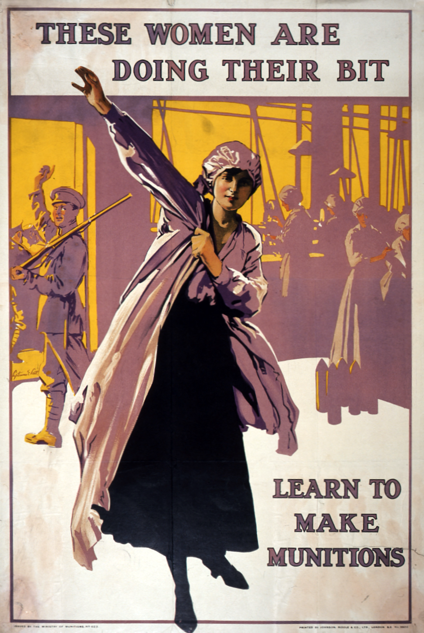

Propaganda poster from the First World War - Image courtesy of the National Archives
Alongside the above resources, and after extensive research around the subject, pupils can explore the song Barnbow Girls from the interview with Roland Kellet. What can we learn from the interview and song sung by the interviewee? Why might the song have been sung? Who might have composed the song? Which words within the song are no longer in use? What do they mean? Do they give an insight into what the Barnbow employees thought about themselves? What can we learn about how other people viewed them?
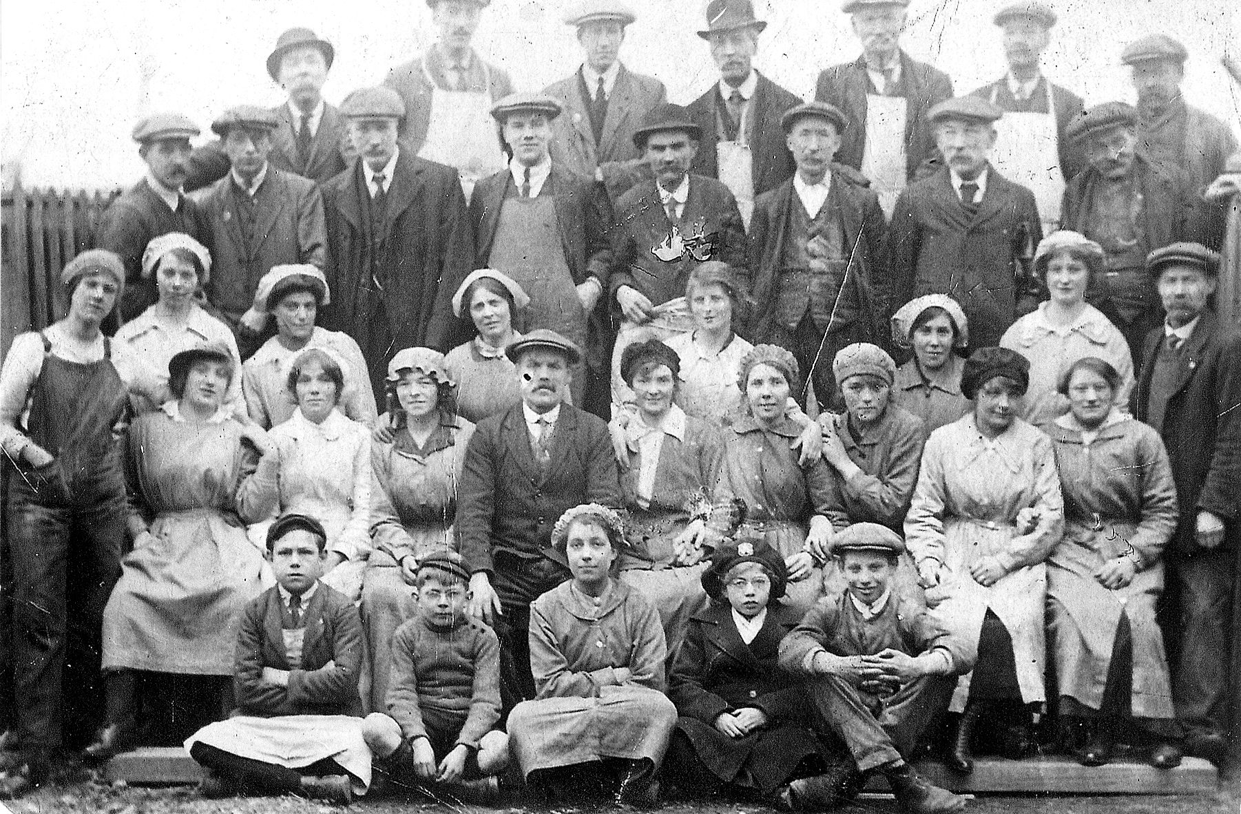
Workers at Barnbow Munitions Factory - Image by kind permission of Leeds Libraries, www.leodis.net (2011411_171999). Copyright: P E Holmes.
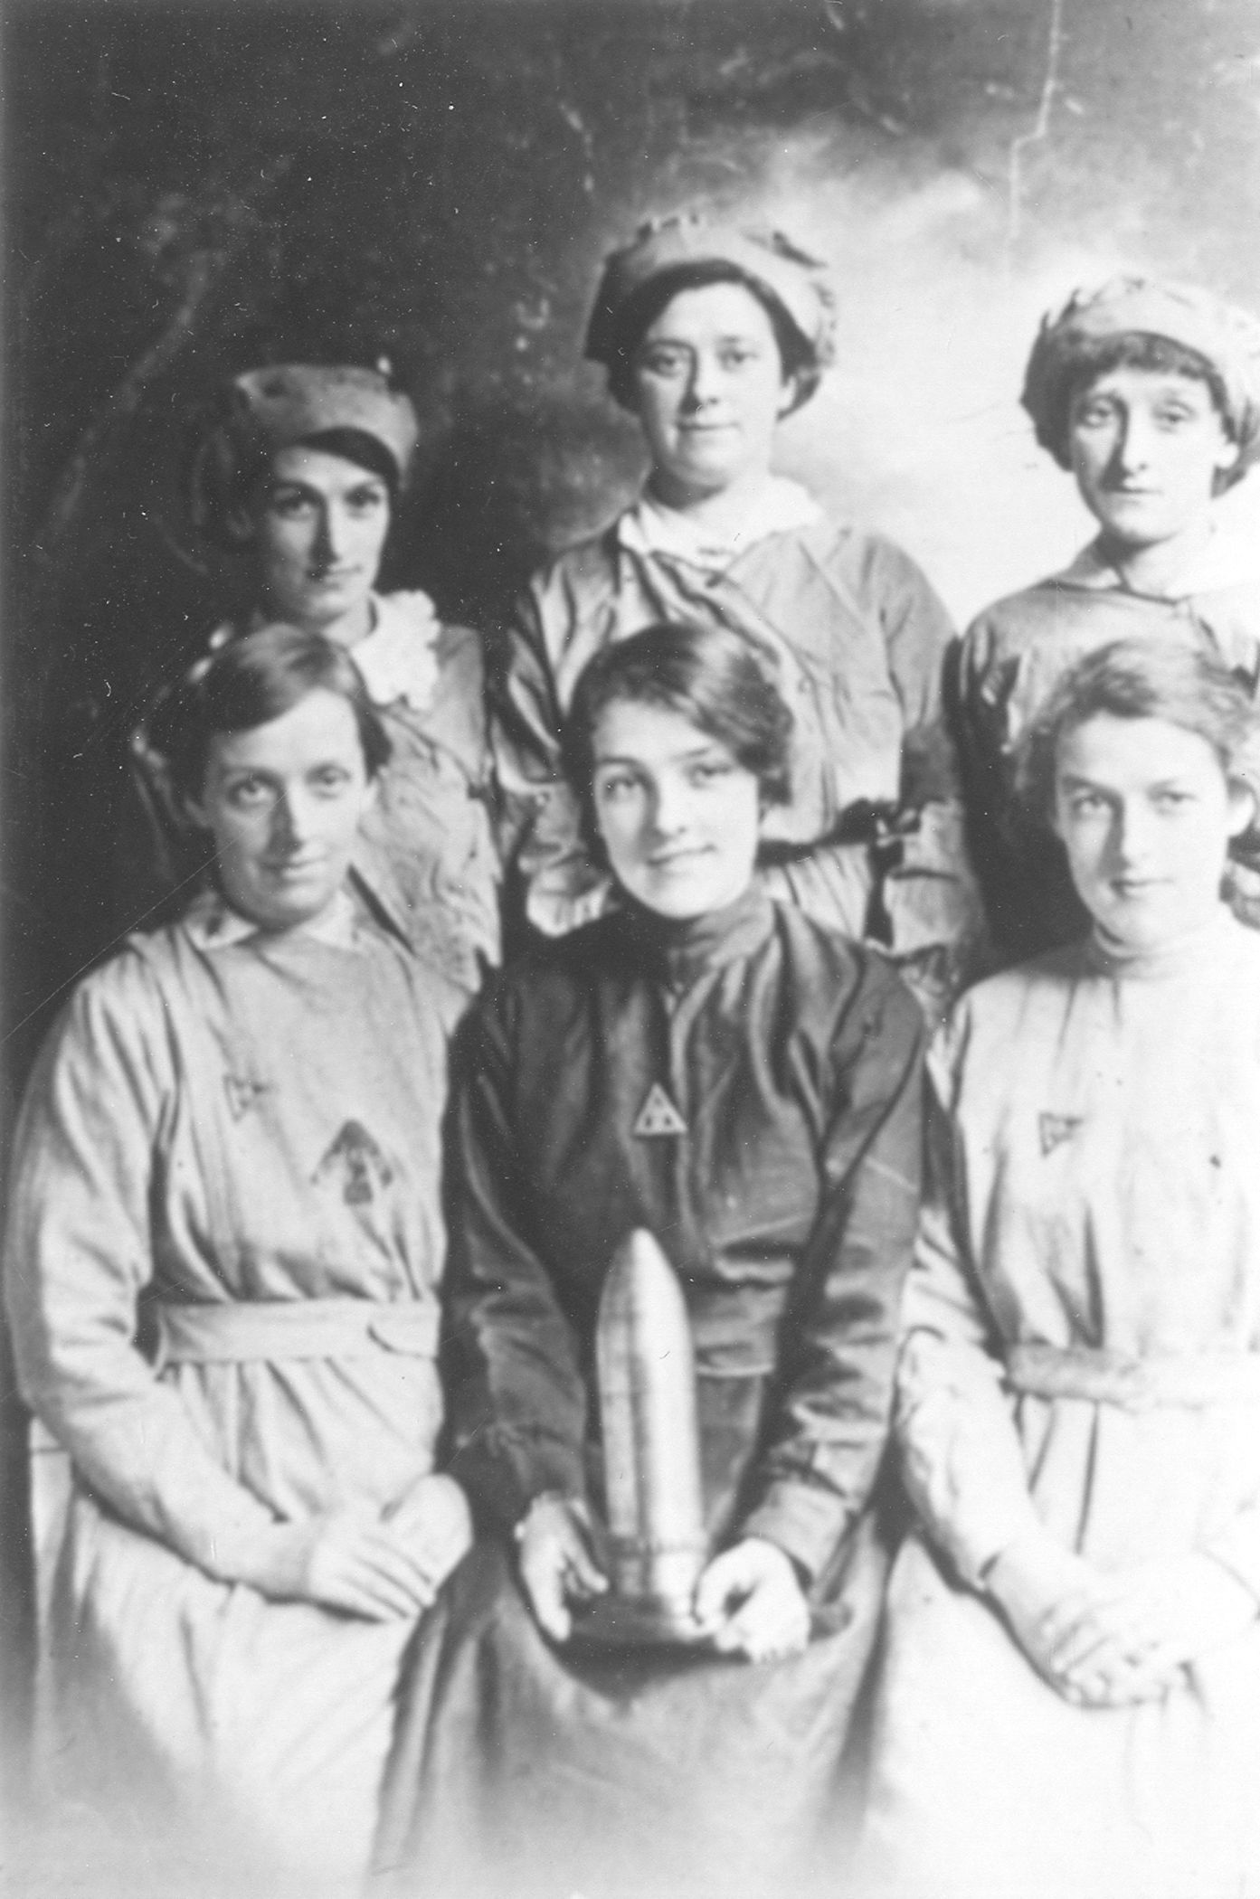
The Barnbow Lasses - Image by kind permission of Leeds Libraries, www.leodis.net (20091019_169611).
In May 1918, King George V and Queen Mary visited the city of Leeds. Can pupils add another verse to the song? A verse fit for royalty? How could the pupils perform the song?

2.1 A historical enquiry into working class life in Leeds in the 1930s

Listen to the recording of Ivy Murray's interview, made in 1999. Ivy talks about her childhood in Hunslet, Leeds.

- Can you understand everything she is saying? Is her accent like yours?
- Now read the transcript of the interview. Use the following questions to develop your own historical enquiry into life in the 1930s in Leeds.

- Compare Ivy’s life to your own. Make of list of all the things that are similar and all the things that are different to your own life.
- What type of industries does Ivy talk about in her interview?
- Do these industries still operate today? Do some research on the internet to find out what industries still exist in and around Hunslet.
- Is there any evidence of cloth and textile manufacturing in Leeds today? Why did it grow in Leeds in the first place?
- The landscape of Leeds has changed in the past 100 years and Ivy mentions specific streets, areas and landmarks. Do the places mentioned still exist? If not, what has replaced them? Is Hunslet now classed as residential, industrial or commercial? Why is that?

2.2 A philosophical enquiry into working class life in Leeds in the 1930s
Philosophy 4 Children uses a structure of 10 steps to support a philosophical enquiry, helping your students to explore different perspectives, engage in critical thinking and conduct research to gain a better understanding of a topic. Use this sequence to explore Ivy’s story:

- Preparation – use open thinking games and questions to warm up the class and break the ice. There are lots of philosophical enquiry warm up games online you can use, just search for ‘philosophy 4 children warm ups’.
- Stimulus – introduce the source of interest, in this case the audio recording of Ivy Murray's childhood memories of Leeds.

- Thinking time – give the class some time to think in silence either directed or undirected about the interview. What are the big ideas and messages in this recording?
- First thoughts – encourage each person in your group or class to share their first thoughts or feelings, a word or phrase, about the interview.
- Question composition – in small groups or pairs, students develop a philosophical question about what they have heard. This might start with ‘I wonder…’

For example you might want to use the following philosophical question: What makes a happy childhood?

- Airing suggestions – Groups share their questions with the whole group. Others can ask questions for meaning or clarification.
- Selection – the class votes which question they feel will be the most philosophically interesting one to explore, the one they are most excited by.
- First words – this stage offers students who thought of the question to explain their thinking and what interested them most.
- Building through dialogue – In this stage the class each shares whether they agree or disagree with what others have said or add detail.
- Final words – one by one each student should be encouraged to reflect on the whole discussion so far in any way. That may be to add more depth, to share the most interesting things they have heard or talked about or to come to some sort of conclusion together.

2.3. A creative enquiry into working class life in Leeds in the 1930s

Develop a piece of creative writing in response to Ivy’s interview. Ivy mentions the sights, sounds and smells of the industrial community within which she grew up.
Your creative writing could be a diary, a story, a poem or a first-person account of A Day in the Life of a 1930s Leeds Child.

2.4 A spoken word enquiry into working class life in Leeds in the 1930s

Look at the transcript of Ivy’s interview. How can you tell this is an interview? Think about punctuation, layout and of course the actual speech and words she uses.

- How much of Ivy’s language is formal or informal?
- Does she use words you don’t recognise or slang words?
- How does her accent differ from the accents you hear around Leeds now? Is it the same? Is it different? Why do you think that is?

3. Childhood memories and playground songs

3.1 Listen to the recordings of children from Quarry Mount School and Quarry Park School and Roland Kellet’s songs made during the 1970s.

- Get into groups of 3 or 4 and choose a rhyme/song that you like the most. What is it about the rhyme/song that you like? Is it the words, the humour, the story or something else?
- Use the transcripts of the songs to learn the rhyme/song as a group. Develop your own creative performance of it for a class ‘poetry slam’ using playground rhymes. You could try developing actions or a clapping or skipping game to go with the rhyme. How should they be performed and could music accompany them? How can we use our bodies (clapping, jumping, skipping) to perform the chants?
- What are the language features within the chant? Are they local and/or regional? What is the structure and organisation of each one? What do they have in common in terms of content and language, structure and organisation? Are they parodies? Are they about things children want in their lives or just observations of other people?
- Use your recording device (tablets, microphones or other equipment to record audio) to record some of the current songs and rhymes from your own playground. Listen to your recordings and transcribe the words. Compare and contrast those with the recordings you have heard from the 1970s.
Think about:
- the content and story within the song
- the language used in the song
- the structure, rhyme and rhythms used in the song
- Try creating new playground rhymes or songs.
- Search the internet to listen to a version of the Clapping Song, recorded by Shirley Ellis in 1965. Try creating your own verse to add to the song.
- Extension work: Carry out some class research into the rhymes and songs that parents, carers and friends sang when they were at school. Write about or record your families, carers, friends talking about or even performing the songs. You could share your class oral histories with another school either nationally or globally.
3.2 Comprehension: playground songs and rhymes
Read the comprehension and answer the following questions in full in your books:

- How are playground songs and rhymes passed on in the oral tradition?
- What event may have inspired the song ‘Ring a ring o’ roses’?
- What influences the content and story of playground songs and rhymes today?
- What was the first clapping game to be written down? What year was this?
- What surprised you most about the information you have read? Why was that interesting?

