Make a Minibeast Guiro (stick strummer)
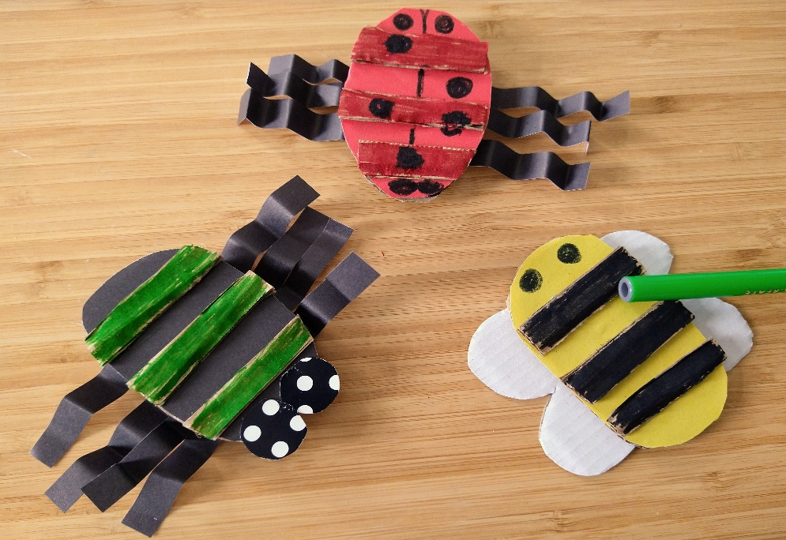

The buzzing we can hear as an insect whizzes by might sound simple to us, but to other insects it can be saying all kinds of interesting things. The buzzing sound happens because insect wings are moving so fast that they cause the air around them to vibrate, which our ears hear as a buzzing or a humming. All insects with wings buzz like this, from the biggest beetle to the smallest fly, we just hear some of them more easily than others.
The buzz changes depending on the size of the insect and how fast they flap their wings; larger insects, like bumble bees, have slower wingbeats than something like a mosquito (which has small wings and very fast wingbeats), so the buzz of a bumble bee is much lower than the buzz or ‘whine’ of a mosquito. Mosquitos even use their buzzing to talk to each other and can control how fast they flap their wings, to change the pitch of their buzzing!

What you’ll need:
- Some thick card (card from a cardboard box is good!)
- Colouring pens
- Thin paper strips for legs
- A pen, pencil or clean lolly stick
- Sticky tape or glue
- Scissors
What to do:
- Draw a minibeast body shape (Spider, Bee or Ladybird) on thick card. Cut it out
- Cut 3 thin strips of thick card
- Stick the strips of card on to the body of your minibeast, and decorate it with colouring pens
- Add legs to your animal. Fold some thin strips of paper back and forward (like a fan) and stick them under the minibeast body as legs– see the examples above. Remember that spiders have 8 legs, insects have 6. You can add wings to the bee instead
- Pick a lolly stick or pen or pencil and use it to strum across your minibeast guiro (strummer) to make a noise!

