Build a Working Waterwheel

Kit list
- Thick card or plasticard (for a more durable waterwheel).
- Pen/pencil
- Plate (to use as a template)
- Wooden doweling (or round pencil)
- Plastic cups
- Scissors
- Adhesive
- Bottle / watering can / hosepipe or dried beans
- Bucket / washing up bowl (or do this outside!)

About this activity
This activity involves building a waterwheel (which could be used to generate renewable electricity) and experimenting with dropping water from a greater height or with greater force to see if it affects the movement speed of the wheel.

Historically waterwheels have been used to power machinery in Victorian mills, and can still be used to generate electricity today.

Instructions
- Use a circular template (such as a plate) and draw two big circles on the plasticard/ thick cardboard.
- Cut out the circles, these will form the sides to your wheel
- Mark the centre of the circles
- Cut a hole in the middle of the circles
- Using split pins or tape attach plastic cups to the edge of the wheel (we recommend you use at least 4 cups). Make sure cups are at around a 45 degree angle to the edge of the wheel.
- Once built push the doweling/ circular pencil through the holes of the wheel.
- Mark a point on the wheel so you can count its rotations.
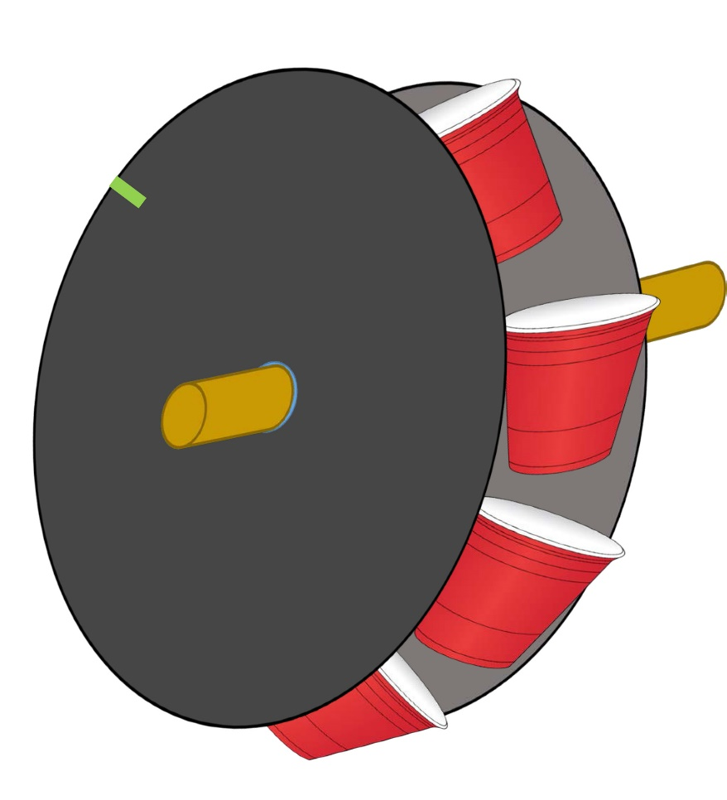
Illustration of a model waterwheel, showing the construction. Plastic cups are used to catch the water and a mark on the outside of the wheel helps to count rotations.

- Time to test! Hold the water wheel above the bucket or bowl.
- Pour water into the waterwheel from above and watch it rotate. You can pour dried beans from a bottle instead of water.
- Try pouring water from a greater height and see if the speed of the wheel increases, or increase the stream of water and observe any changes.

Example table of findings (scientific investigation)

Height water poured from | Number of wheel rotations in 30 seconds
1cm
10cm
20cm
30cm

Electricity at home
How is the electricity you use at home generated? Can you think of any alternative sources homes could get their energy from in the future that would make for a more sustainable planet? How could these work?

