List of Materials and their Medieval Properties

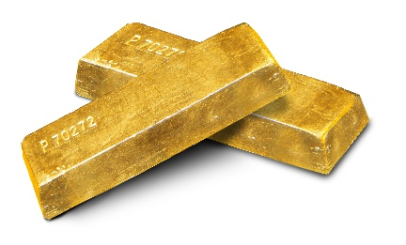
Gold: the most valuable and popular metal, easy to shape

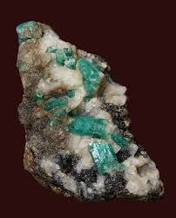
Emerald: believed to prevent epileptic fits and stop storms

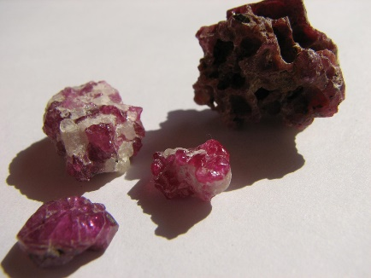
Ruby: believed to protect against spiritual poison and physical poison by air or water

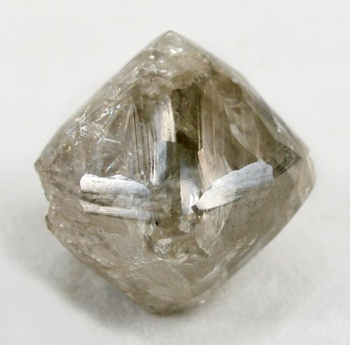
Diamond: believed to protect from bad dreams, to cure heart problems, and guarantee victory over enemies

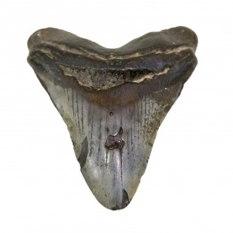
Shark’s tooth: believed to detect poison

All images: Wikimedia Commons

