Record of War work from Hunstanton Guide Company logbook 1939-45

Maths Activity Sheet

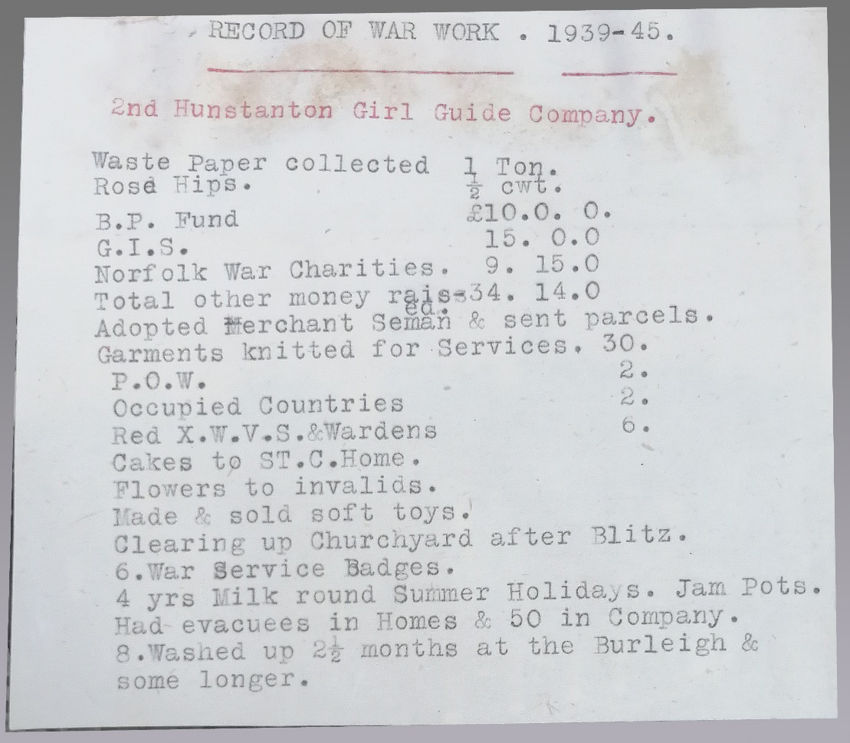
Use the Record of War Work below and your research skills to answer the questions.

- The Hunstanton Guides collected 1 ton of waste paper.
How many kilograms are there in 1 Imperial ton?

- At this time, money was counted in imperial amounts rather than decimal. There were three denominations of money. Find out what they were called.
a) b) c)

- How would you say the following amounts of imperial money?
£10.0.0 £9.15.0

- How much money was raised in total?

- £1.0.0 then = £30.18 today.
What is the equivalent amount that was raised in today’s money?

