Educational resources: An Overview of the Holocaust
Information for teachers: this worksheet draws upon original primary sources from The Wiener Holocaust Library’s archive to give an overview of the Holocaust and challenge common misconceptions.
All sources are courtesy of The Wiener Holocaust Library (unless otherwise specified) and can be reproduced for educational purposes only. The Wiener Holocaust Library should be acknowledged in all reproductions.
The Wiener Holocaust Library is the world’s oldest archive of material on the Nazi era and The Holocaust. The Holocaust Explained is Library’s educational website, designed for schools. https://www.wienerlibrary.co.uk/ https://www.theholocaustexplained.org/
The Wiener Holocaust Library works closely with the University College London Centre for Holocaust Education. For more resources, support and guidance on teaching the Holocaust visit their website: https://www.holocausteducation.org.uk/teacher-resources/

Possible age groups: 16-18 year olds: (England and Wales) KS 5 and may be suitable for use with KS4 with background knowledge as described below. Not suitable for KS3.
Relevant curricula (England and Wales): A-Level History - Germany and West Germany, 1918–89; OCR History Democracy and Dictatorships in Germany 1919–1963; AQA History: Democracy and Nazism: Germany 1918-1945.
Prior knowledge assumed: some knowledge of the nature of Nazi beliefs, antisemitism and awareness of the main features of Nazi rule. Knowledge of the context and development of the Second World War.
Session aims: the overall aim of the session is to establish key, but often misunderstood, features of the Holocaust.
Use contemporary source material and maps to:
- Understand the key features of the Holocaust:
  - what was the Holocaust?
  - when did it occur?
  - where did it occur?
  - who were the victims of the Holocaust?
  - who were the perpetrators of the Holocaust?
Suggested activities: Specific suggested tasks/ questions about each source can be found throughout the worksheet. Students could be given a few moments to write up their answers to the questions, one by one, and then the whole class could discuss. Or the all of the questions could be initially discussed by the whole group, led by the teacher.
Definitions of words in bold can be found in the glossary at the end of the worksheet.
Supplementary information for teachers about the sources and the topic can be found after the worksheet.
Worksheet: An Overview of the Holocaust
Tasks: examine the photographs, maps and documents below and answer the questions
- Examine this photograph. It was taken by a member of the SS, a Nazi organisation, in Warsaw during the Holocaust. Who do you think is shown in this photograph? What is happening here?
- What do you understand the term ‘the Holocaust’ to mean?
- The Holocaust was an example of a genocide. Do you know what the term genocide means?
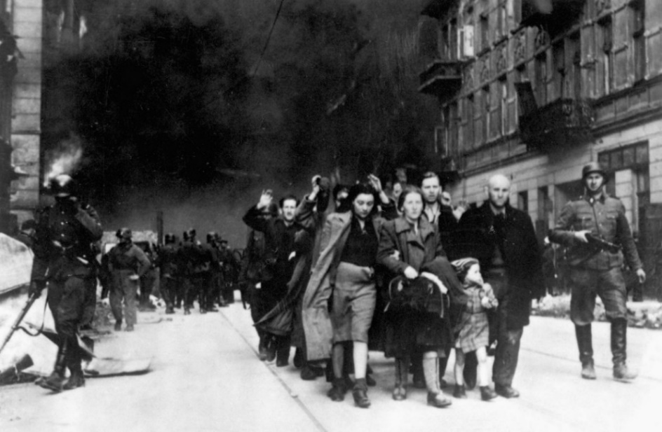
- Examine the photograph below. What do you think it might depict?

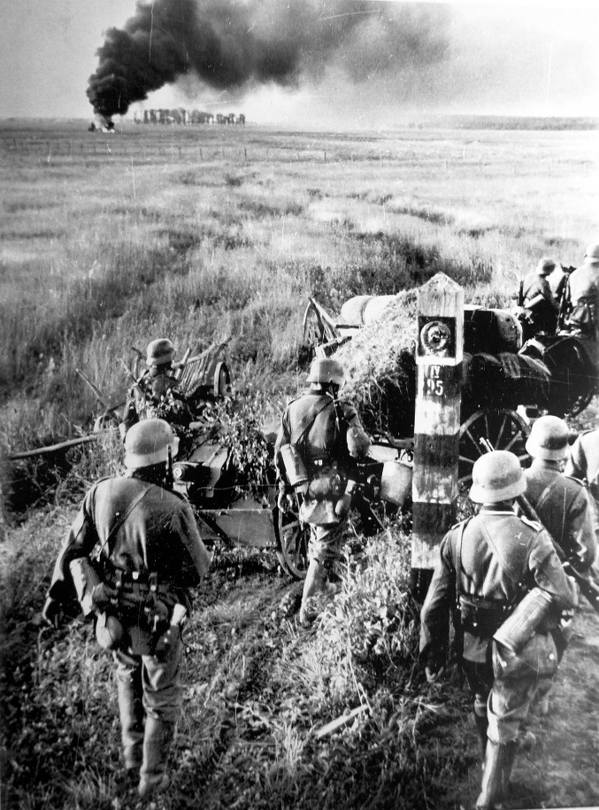
- In what year might this photograph have been taken?
- Do you think that there is any connection between the events depicted in this photograph and the Holocaust?
- When do you think the Holocaust occurred?

- Study the map below. It indicates the approximate size of Jewish populations in European countries at the time that the Nazis came to power in Germany.
Where do you think the Holocaust took place?
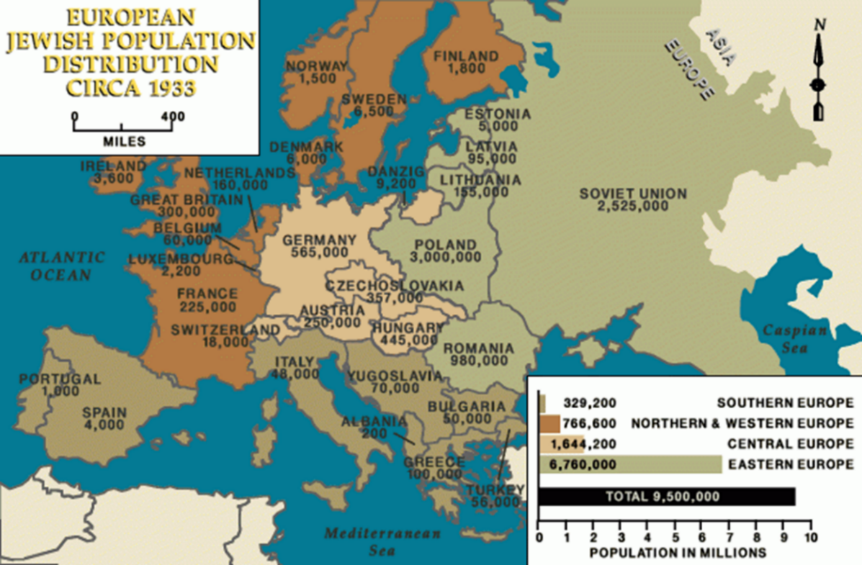
Maps: © USHMM

The ‘Holocaust by bullets’
The Holocaust started at the time of the German invasion in June 1941 of the Soviet Union during the Second World War. As the German army advanced through the Baltic states, Belarus, Russia and Ukraine, SS killing squads, called Einsatzgruppen, and their collaborators organised mass shootings of Jews and others. Around half the victims of the Holocaust were murdered in these areas.
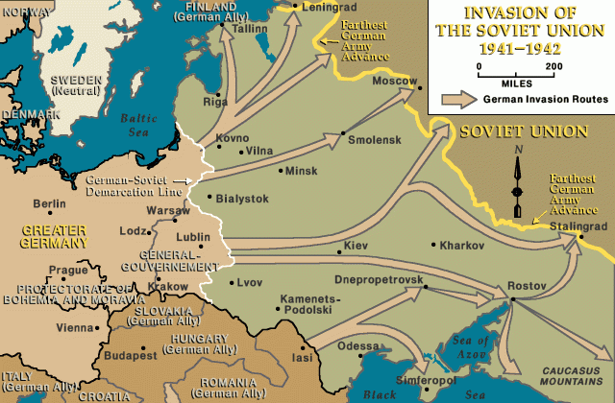
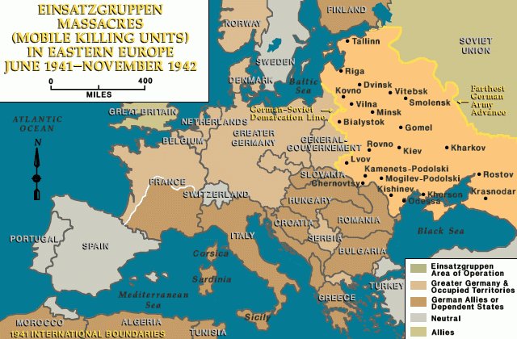
- The map below is from a SS report. What part of the world / countries does it depict?
- What do you think that the map shows ?
- What the Nazis’ ultimate aim for the Jewish population of these areas?
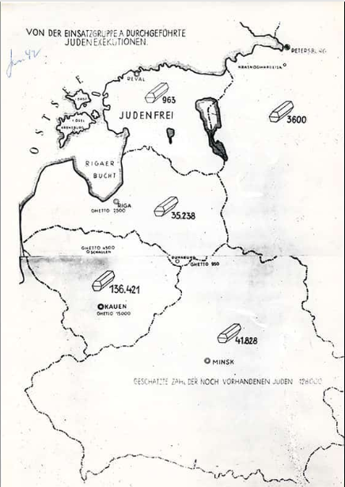
The Holocaust in camps
The Nazis had an extensive network of camps across Europe. In August 1942, experiments started at Auschwitz with the use of gas to murder people. By 1942, mass murder of Jews by gas was being carried out at Auschwitz and other extermination camps, such as Sobibór, Chełmno and Treblinka. In camps which were also labour camps, such as Auschwitz, some Jews were selected for slave labour.
- Look at the map. Where were the extermination camps situated? Were they in the main part of Germany?
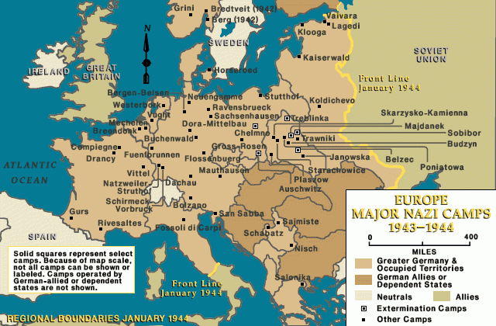

Transports
- Find the names Augusta Spitz and Therese Steiner on the list on the next page.
Spitz and Steiner were two Austrian Jewish women who lived in Guernsey in the Channel Islands. The Channel Islands were occupied by Germany during the Second World War. Spitz and Steiner were arrested in Guernsey and deported to France, and then to Auschwitz.
Jews from across Europe were transported by train to the extermination camps. This document is a list of those deported to Auschwitz from a camp, Drancy in France, which arrived in Auschwitz on 23 July 1942. Spitz and Steiner were murdered in Auschwitz.

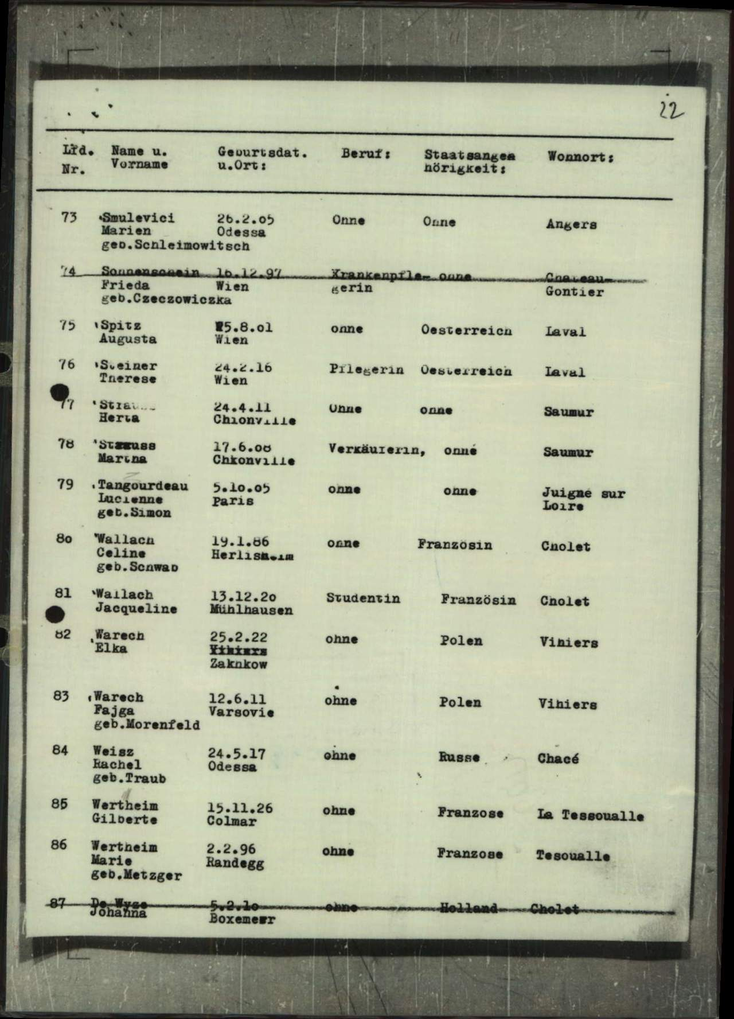
International Tracing Service Archive, Wiener Holocaust Library Collections, Document 11179855#1
Who were the victims of the Holocaust?
German Jews
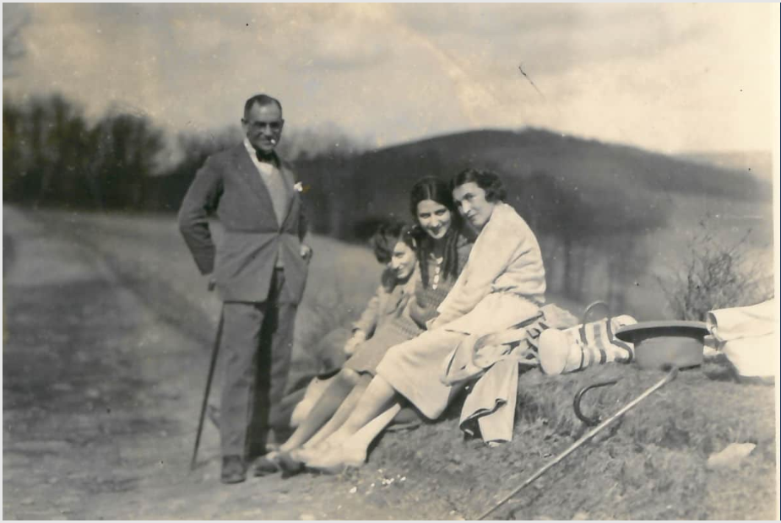
Members of the Robinsohn family on a walk in Germany, 1928. In the late 1930s, the Robinsohn family left Hamburg and emigrated to Britain.
Jews from across Europe: the vast majority, around 97%, of the Jews murdered in the Holocaust were not German. Of the approximately six millions Jews who were killed, around two million of them were Polish.
Eugen and Helene Fürze, a family with Jewish roots, relax with their family and friends. This photo was taken in the 1930s in Susice, Czech Republic. Eugen emigrated to Britain with his father and son in 1938. His wife Helene stayed with her mother in Prague. In 1942 she was murdered by the Nazis, likely in Majdanek (a concentration and extermination camp in Poland).
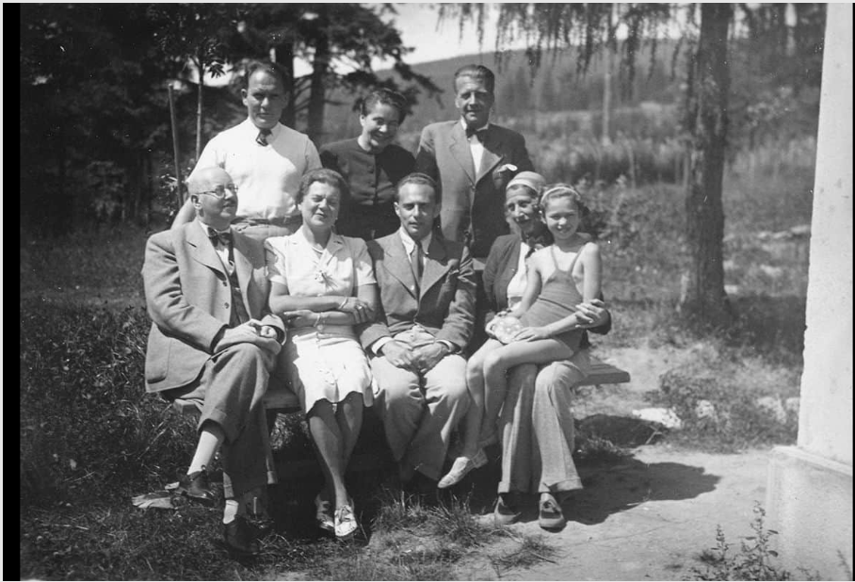

Roma
Up to about 500,000 Roma were murdered by the Nazis and their collaborators in extermination camps and in mass shooting in Soviet Territories. Roma were considered racially inferior by the Nazis and targeted for murder.
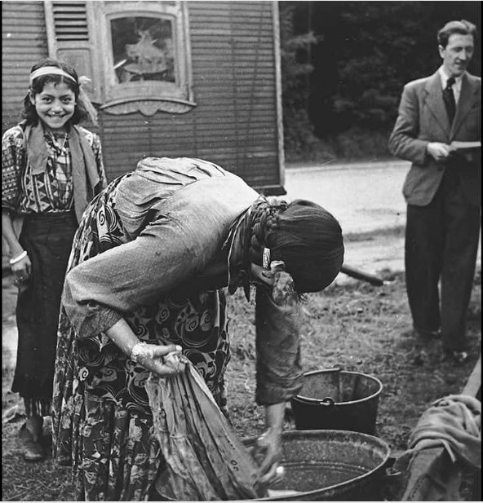
A Roma family in Europe, 1930s, USHMM © Kore Yoors
Should not be reproduced without permission of USHMM.

Who were the perpetrators of the Holocaust?
- Read this document by Oswald Pohl, a senior SS administrator of concentration and extermination camps. His statement was given as part of the Nuremburg War Crimes tribunal. Who does Pohl blame for the programme to exterminate the Jews at Auschwitz?
- Do you entirely trust his account?
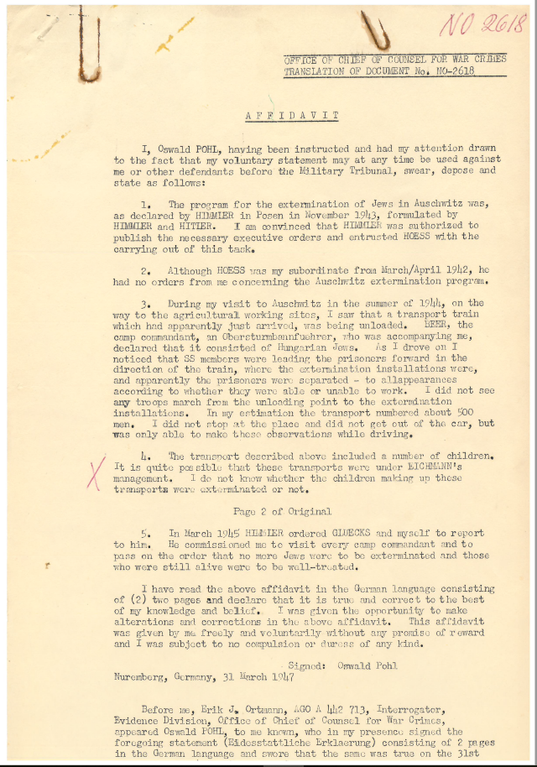
Collaboration
The Nazis were assisted in their campaign of genocide by collaborators from countries other than Germany. This photograph shows German soldiers photographing an attack on Jews in Lvov, in the Ukraine in 1942. The local population, and not Germans, were carrying out the attack.
Sometimes collaborators carried out their own attacks, sometimes they joined the Nazis, for example in the SS. In some countries, for example Croatia, pro-Nazi regimes committed genocide.
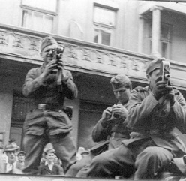

Teacher notes
General:
The key aim of the session is to establish that the Holocaust took place between 1941 and 1945, in the context of the Second World War, and that mass murder primarily occurred in Poland and eastern Europe.
The primary victims were not German Jews, although clearly they were affected. The Holocaust affected Jews from across Europe, and many countries (for example, Poland) had much larger Jewish populations than did Germany.
The session also aims to emphasise that the Holocaust was not all about Auschwitz, which is often the most familiar camp for students. There were other death camps, and a large proportion of the victims of the Holocaust were murdered in mass shootings in far eastern Europe.
The session also includes some consideration of the victim groups (Jews and Roma – who were also targeted in a racist genocidal campaign). The 1.5 million Soviet prisoners of war deliberately starved to death might also be included as victims of genocide. There were other groups of victims of the Nazis who were targeted for attack but who were victims of persecution and not genocide (such as homosexuals, political opponents, the disabled). Although there were murders of members of all of these groups, the Nazis carried out a systematic campaign to eradicate the disabled in Germany.
The session also includes mention of some of the features of the Holocaust that could be considered further, such as the arrests and transportation of Jews, and the use of Jews as slave labour (‘extermination through labour’).
Specific questions:
- The photograph was taken as part of an SS report into the crushing of the Warsaw ghetto uprising and the ‘liquidation’ of the Warsaw ghetto in 1943. Jews are being rounded up for transportation to death camps, guarded by members of the SS.
- YOU MAY NOT WANT TO GIVE THE ANSWER TO THIS QUESTION AT THIS STAGE. The Holocaust refers to the murder of around six million European Jews by the Nazis and their collaborators between 1941 and 1945. The term sometimes also refers to the genocide of around 500,000 Roma at this time.
- Definition of genocide: the organised and deliberate killing of a group of people, particularly those of a particular ethnic group or nation.
- The photograph depicts the German invasion of the Soviet Union in June 1941
- 1941
- The Holocaust occurred during the Second World War; the mass killings started at the time of the invasion of the Soviet Union.
- 1941-1945.
- YOU MAY NOT WANT TO GIVE THE ANSWER TO THIS QUESTION AT THIS STAGE. German-occupied Poland, far Eastern Europe (ie the Baltic states and the Soviet Union – Belarus, Ukraine), and elsewhere (eg Croatia)
- The map shows the Baltic states of Estonia, Latvia and Lithuania (which had been under Soviet domination since 1939), as well as the Soviet states of Russia and Belarus.
- The numbers of mass killings of Jews in these areas. The map dates from 1943.
- Across Estonia, it says ‘Jüdenfrei’ – Jew free – the Nazi’s aim was to murder all Jews in these areas.
- German-occupied Poland, far Eastern Europe (ie the Baltic states and the Soviet Union – Belarus, Ukraine)
- Pohl blames Hitler and Himmler.
- Pohl is likely trying to exonerate himself; to use the defence that he was just following orders.

Glossary
Baltic States – A term used to refer to the countries of Lithuania, Latvia, and Estonia.
Collaborators - Helping another person to carry out an act. In this context the act is usually evil or illegal.
Extermination camps - Extermination camps were camps set up by the Nazis from 1941 to 1945 to murder Jews, Roma, Poles, Slavs, Soviet prisoners, political opponents, homosexuals, Jehovah’s Witnesses, and others thought to be ideologically undesirable. Over three million people were killed at these camps over the course of the Holocaust.

