
The legendary story of Romulus and Remus

This is the story of how Rome began.

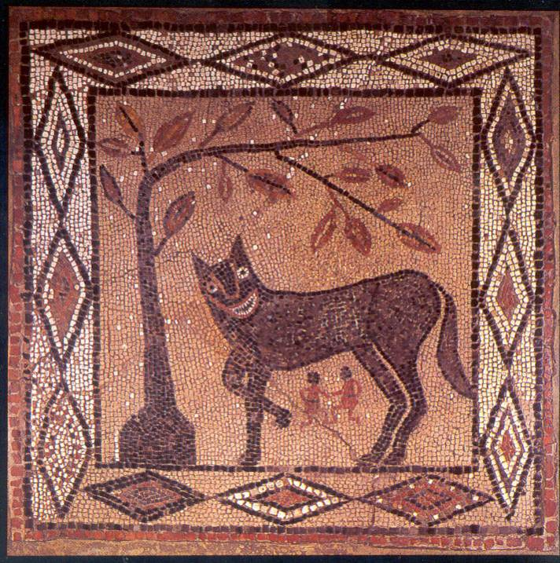
There were twin brothers called Romulus and Remus, whose father was Mars (the God of War) and whose mother was Rhea Silver (the daughter of the King, Numitor). Numitor’s brother, Amulius, had stolen the throne from Numitor, making himself King.

Amulius was extremely angry when Romulus and Remus were born, as he was scared that they could take the throne from him. He stole the two children, placed them into a basket and threw them into a river, wanting them to drown.

The boys were found by a she-wolf who rescued them, cared for them and fed them with her milk. They grew up with the she-wolf until they were found by a shepherd called Faustulus. Faustulus took Romulus and Remus home with him and cared for them until they grew up.

When Romulus and Remus were older they learnt who they actually were and about what Amulius had done. They decided that they would kill Amulius, so that their grandfather could become King once again.

After doing this they decided to build their own city together, that they could rule. They could not agree where to build the city with Romulus wanting to build it on Palatine Hill and Remus wanting to build it on Aventine Hill. Due to this they decided to each build a city of their own.

Both Romulus and Remus built walls around their cities, but when Remus visited Romulus he easily jumped over his wall and made fun of how small it was. This annoyed Romulus who then killed Remus and declared that he would kill anyone who did the same or tried to break into his city that he had named Rome.

