**Barnbow Lasses Worksheet 2**

BD06300_

**A Day in the Life of a Barnbow Lass**

**Fictional letter from Barnbow worker Agnes Sykes to her soldier boyfriend, Alfred:**

26th June 1916

Dearest Alfred,

There is some good news about mother, who is much better now. I paid the doctor’s bill out of last week’s wages, though mother made a fuss. I still had plenty of money left. I have sent this photograph for you. Your friends will probably think I look like a boy, but it’s how we dress and is a proper uniform, like yours but not as smart.

I am back on the early shift now – 6am to 2pm. I told Mrs Sparrow that my mother needed me home early, as mother was not well, so she let me change shifts. She is such a lovely woman. As usual, I got up at 4.30am so I have time for some breakfast.

The Leeds tram was late this morning. I walked up to the policeman at the entrance, showing my travel permit. They do a thorough job and search your pockets for matches and cigarettes. Then I walked down Barnbow Lane and over the sidings to my section. There are still some wild flowers at the side of the road.

Me and Edith are working in Room 42 at the moment, but on different shifts. It has been raining hard for the past four days, so the ground is really muddy and all my leggings and shoes were clarted up with it. But it is no matter, compared to what you are suffering.

First I take my hairpins out, tie my hair up with ribbon and put it under my cap. Metal pins could cause a spark and I always wear wooden or Bakelite buttons now, for the same reason. Then it is “shoes off” and hop over the barrier to the clean side to put my danger shoes on, which are soft and have no tread.

There are two Danger Women watching us, dressed in red. They search us again, to make sure we don’t go in with anything metal on us. I come to work with my cotton coat and trousers on with leg wrappings round from my ankles up to my knees, so there’s nothing wafting about to get caught round a shell.

Now I fill shells, so I am a proper little Canary and as you know I can sing like one as well! Edith and I laugh about it because we look like a couple of Chinawomen. My hair and skin and nails have turned quite yellow with working with the dry powder, but it’s really good money even though it’s uncomfortable and makes me feel sick sometimes.

I am on five pounds and three shillings a week now and it will go up to ten pounds or more as I get more experience. The yellow powder is lyddite. It coats everything in the room – even the windows and walls – making us all sneeze. It really catches in your throat. We drink lots of milk, which helps and we can have as much as we like.

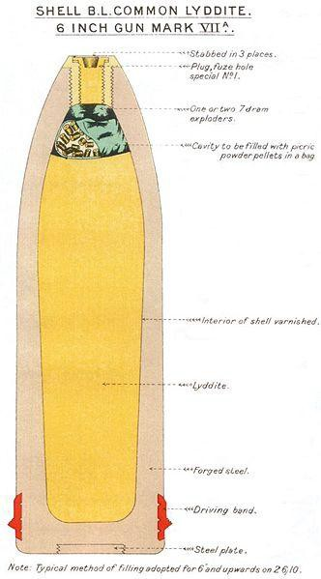

The Lyddite comes in wooden tubs. We sift it and pack it in cans, and then put them in a water tank, which is boiled up until it melts into a kind of vinegar, which we pour into the shell cases. We put a mould inside the shell casing first. It contracts when it cools and we pour beeswax down the little gap and put some cardboard washers on top.

When that’s cool, out comes the mould to leave a space which is filled by the TNT exploder bags. Then the freeze cap must be screwed in and held in place with two screws. We must not drill straight into the detonator or that will set it off.

We get a break at the main canteen for half an hour, though it takes us a while to walk there and back. We get salty bacon and fresh bread, or bread and corned beef and plenty of stewed tea.

The new Charlie Chaplin film is out now - The Fireman. We are going with Maggie Monkman – “our Peggy”, who is a real firegirl, so that should be funny.

Anyway, God keep you safe my love,

Your Agnes.

**[This fictional account was inspired by the real memories of two WW1 munitions workers, Margaret Monkman, who worked at Barnbow, and Mrs Hall, a First World War munitions worker who worked at the Perivale Royal Filling Factory in London.]**

**Now answer the following questions below:**

|  |  |  |
| --- | --- | --- |
| 1 | What is cordite? |  |
| 2 | In June 1916 Agnes had to pay for the doctor to visit her mother. Do some research and find out why she had to pay? |  |
| 3 | How much do you think £5 3 shillings would be worth today? Use the website below to help you work this out: <http://apps.nationalarchives.gov.uk/currency/> |  |
| 4 | What would you *not* be let through the gates of the No 1 Filling Factory without? |  |
| 5 | Name four things you would not be allowed to have on your person if you were working at the Barnbow Factory | 1  2  3  4 |
| 6 | What sort of clothes would you wear to work at the Barnbow Factory? | a  b  c |
| 7 | If you worked in any of the Powder Filling rooms, what nick-name would you have had? |  |
| 8 | What is the most dangerous part of filling a shell? |  |
| 9 | What sort of food and drinks would you be given at work? | a  b  c  d |
| 10 | Do you think that filling shells is a healthy occupation? Explain the reasons for your answer. |  |